# Hadoop Installation

## Hadoop version check

Run “$ Hadoop version” to ensure Hadoop is installed on VM and check its version.

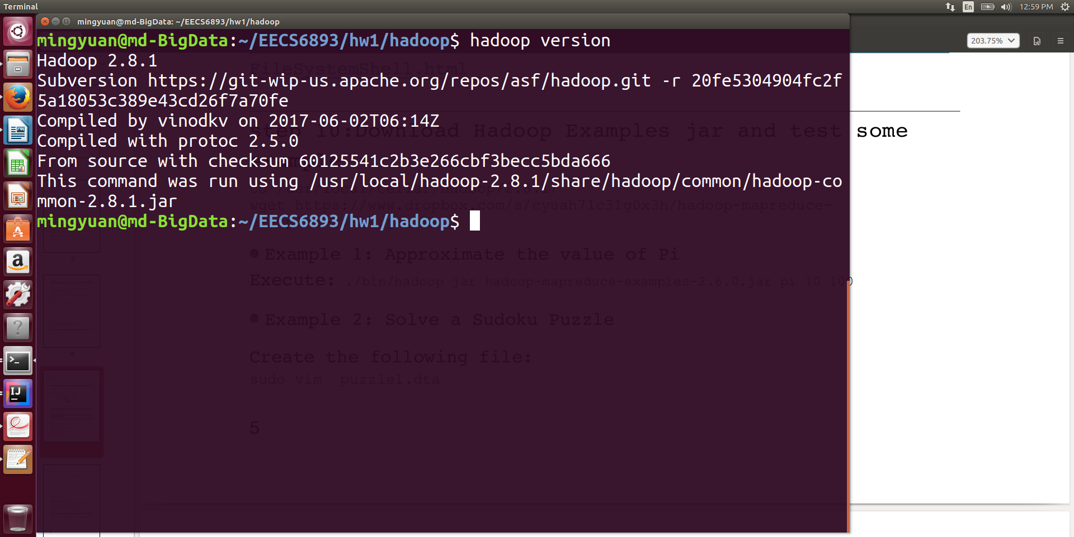

Pic1. Hadoop version check

## Running Hadoop examples

1. Pi calculation

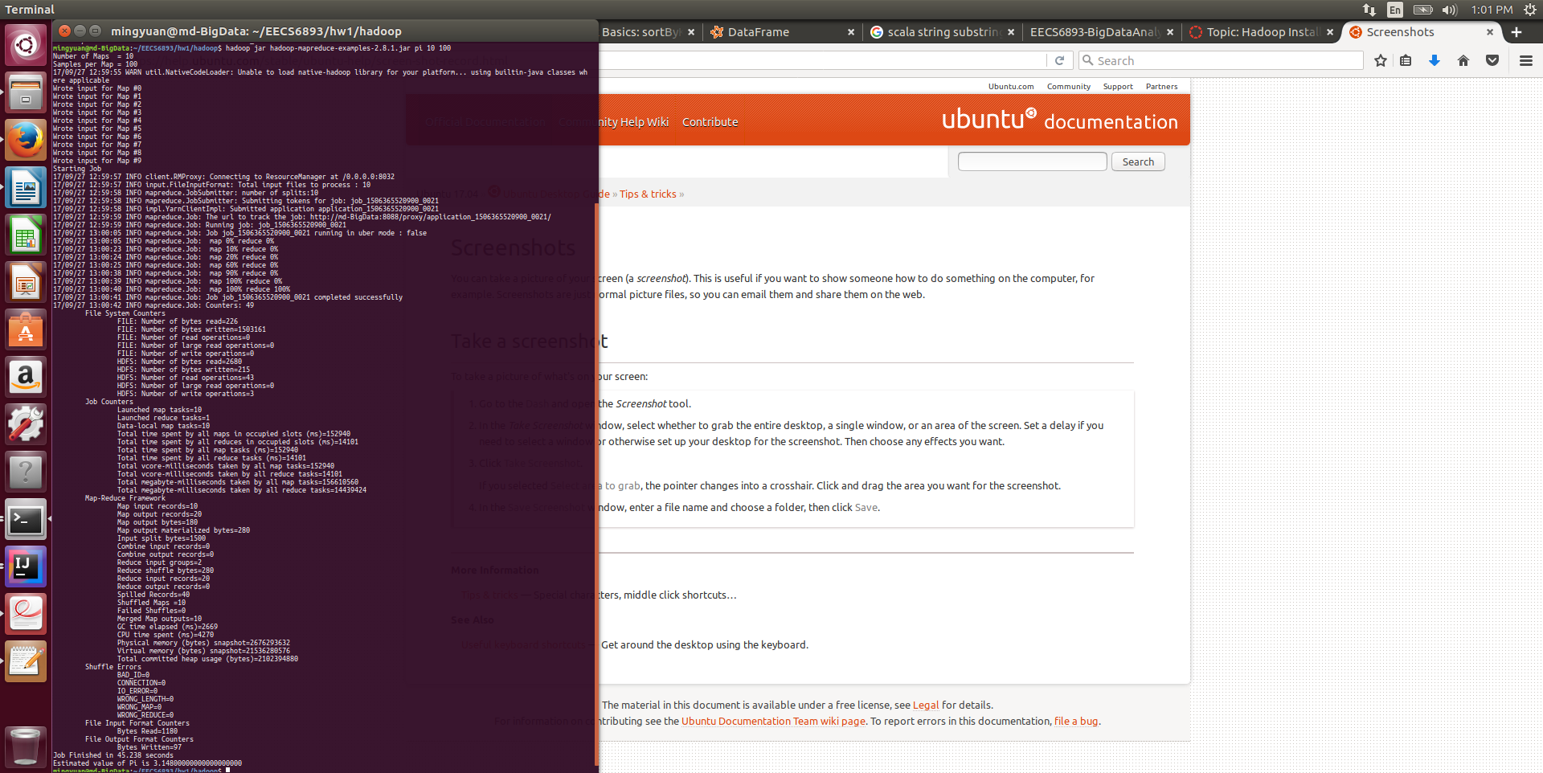

The result of Pi calculation given arguments “10 100” is 3.140000000000000000

1. Sudoku puzzle solution

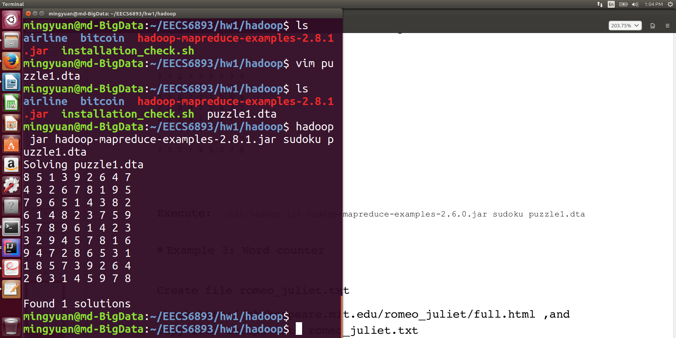

1. Wordcount
   1. Running word count job

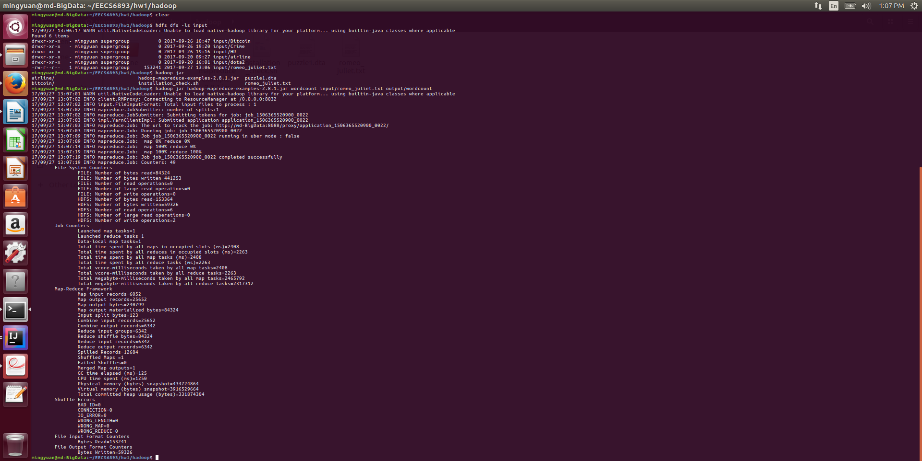

* 1. MapReduce job results

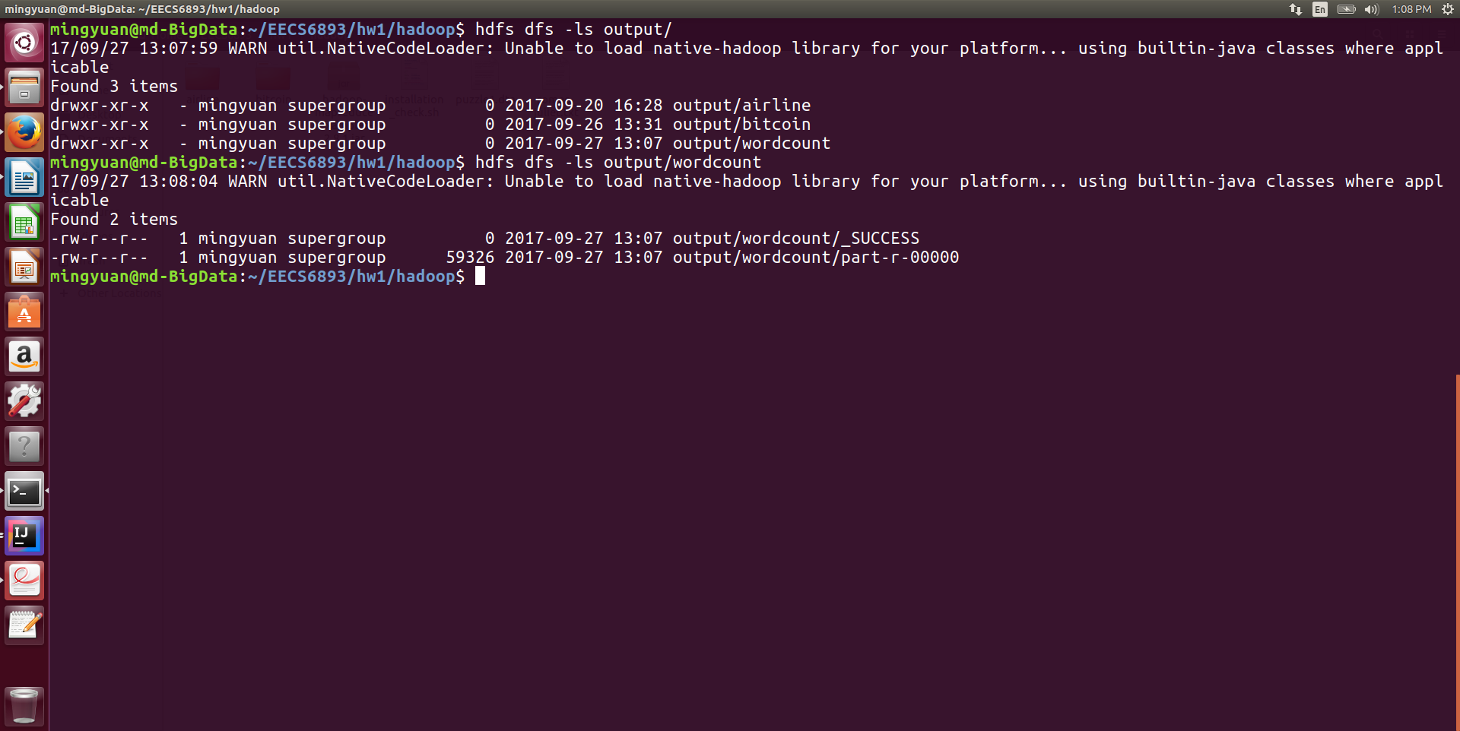

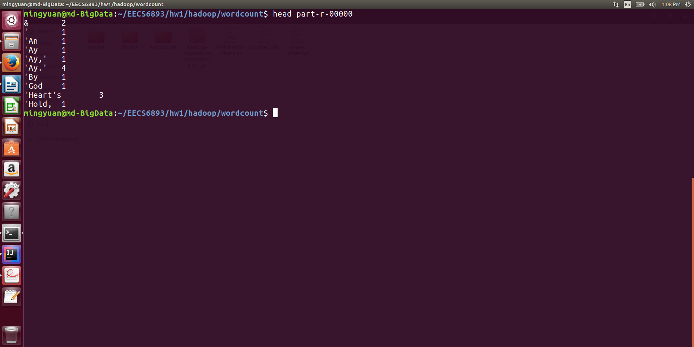

# Datasets

## 1. Employee resign dataset

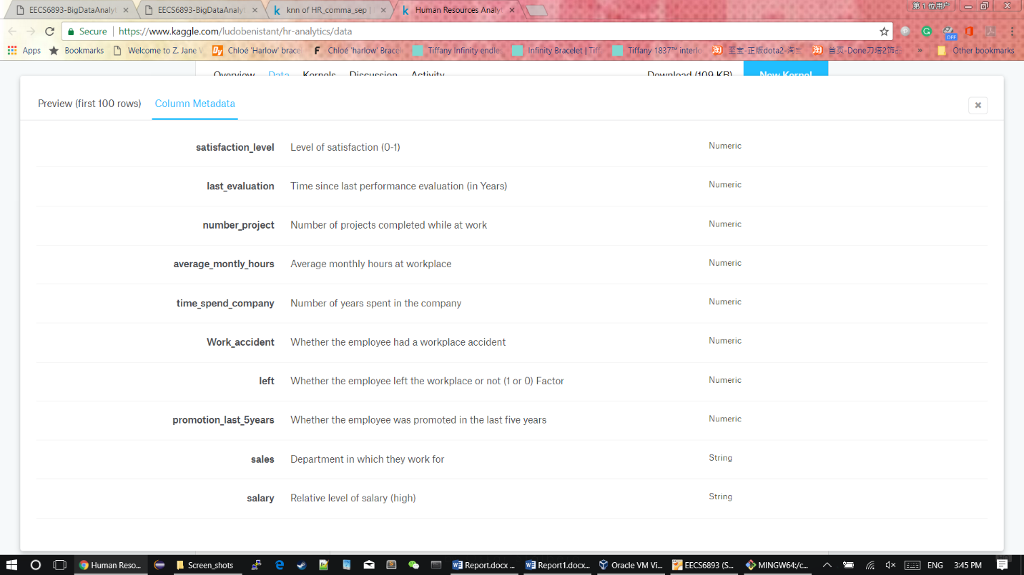

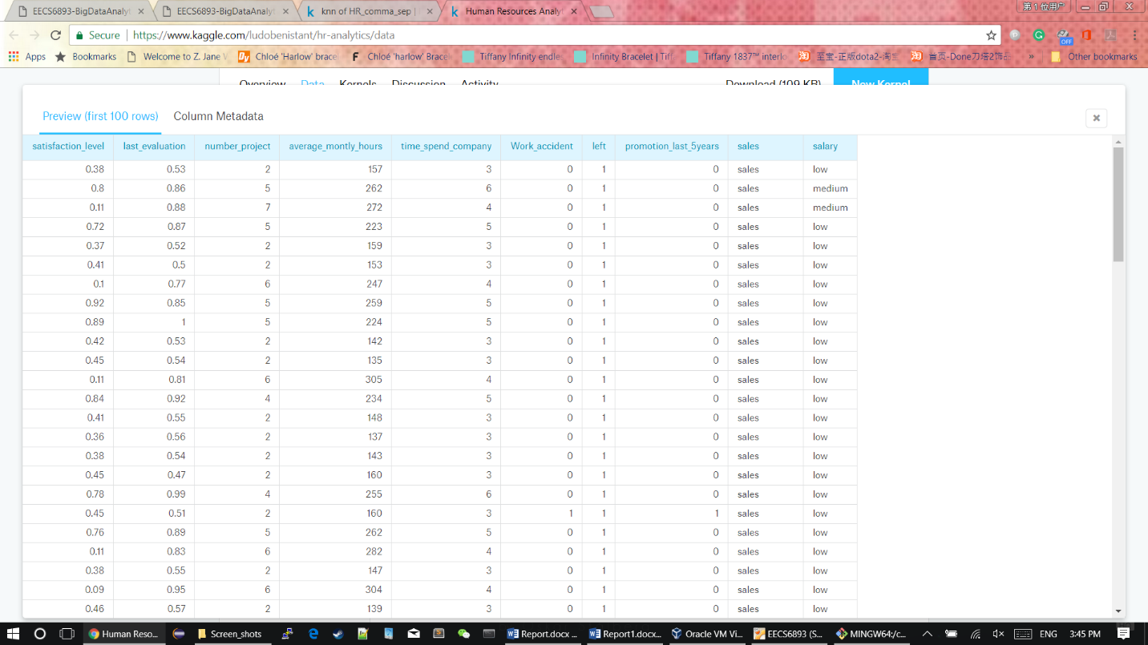

## 2. San Francisco crime dataset

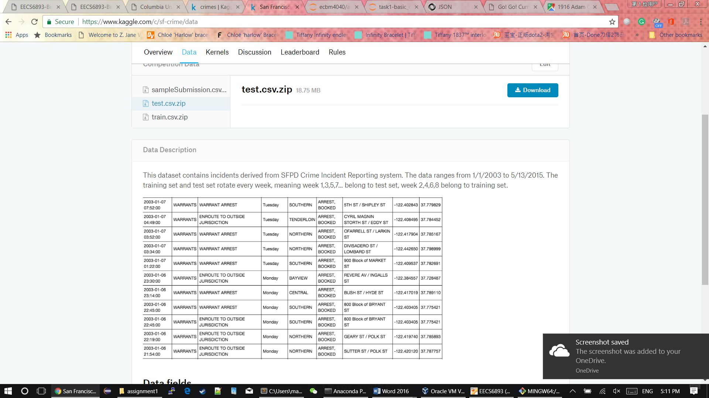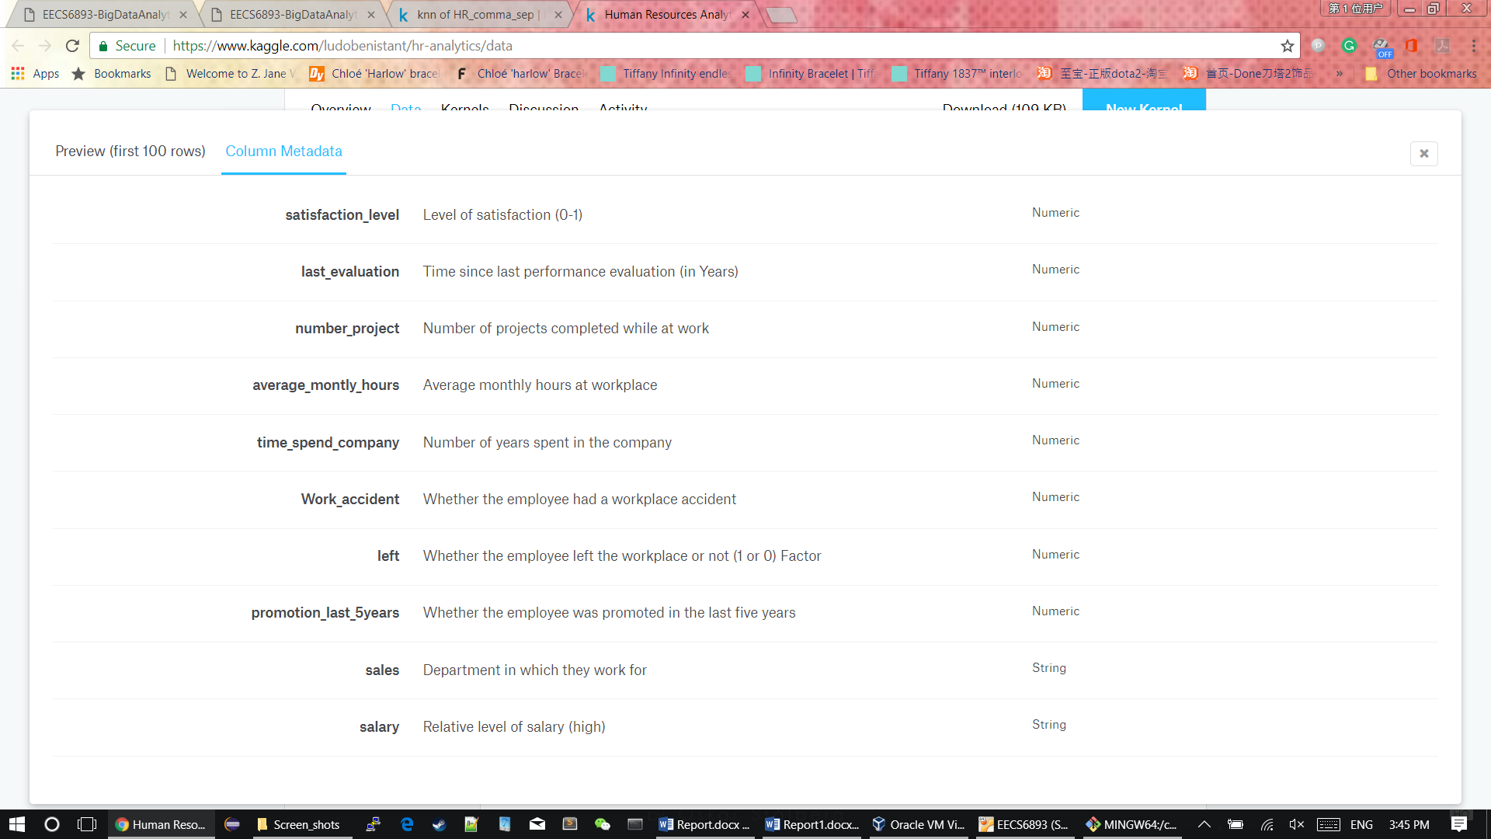

## 3. Dota2 player ratings dataset



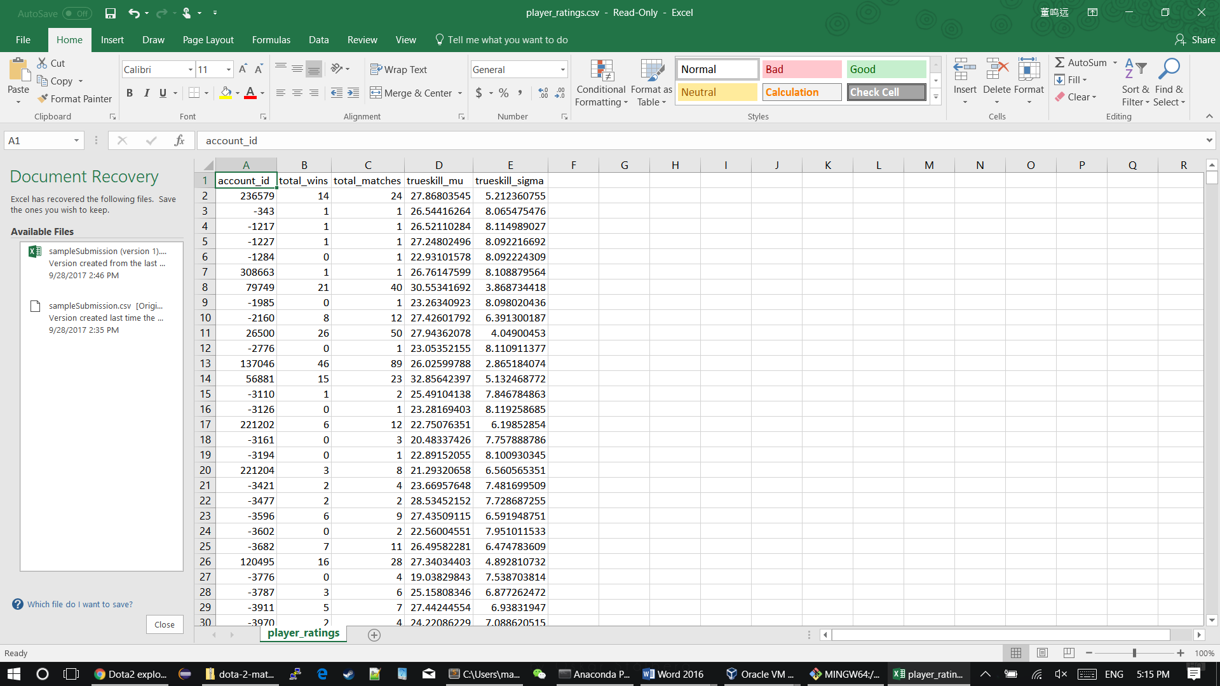

# Hadoop Operation

1. -mkdir

2. -ls

3. -put

4. -stat

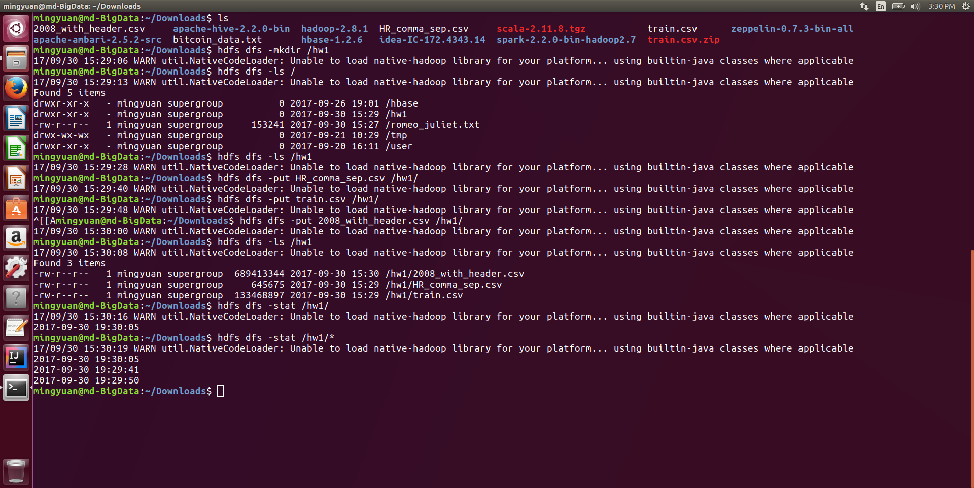

5. -mv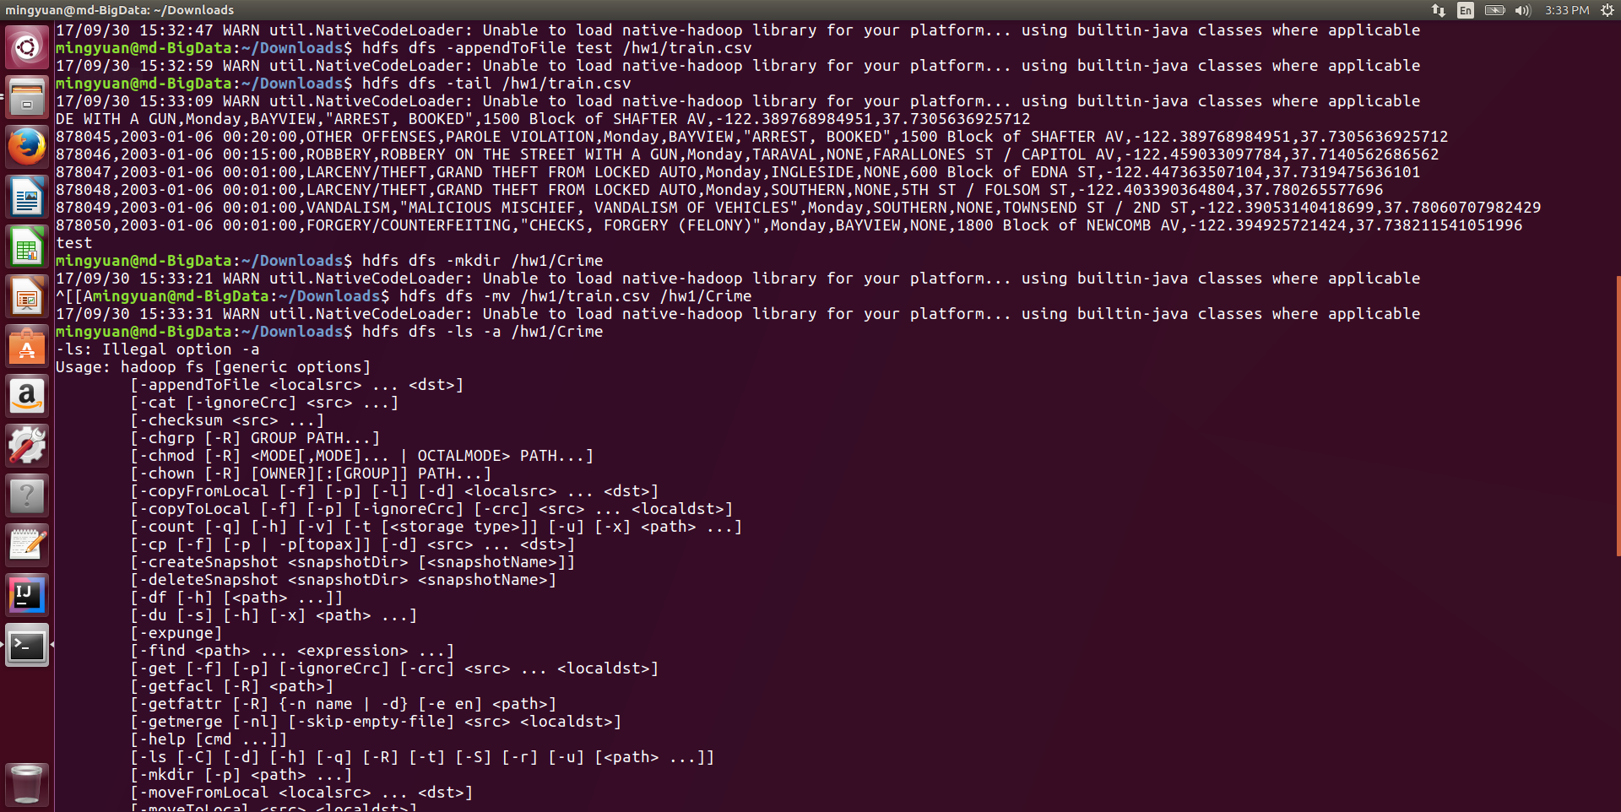

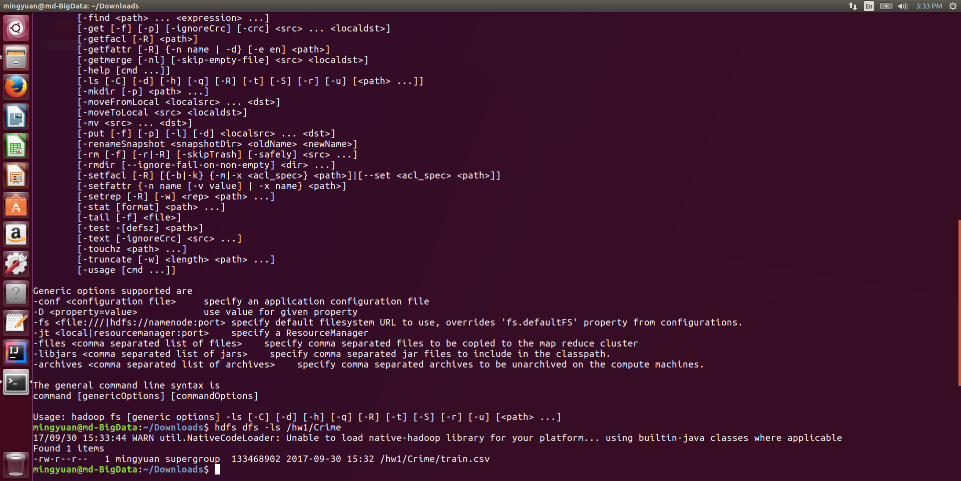

6. -appendToFile

7. -tail



# Hbase query

## Dota2 Dataset

1. Dataset example

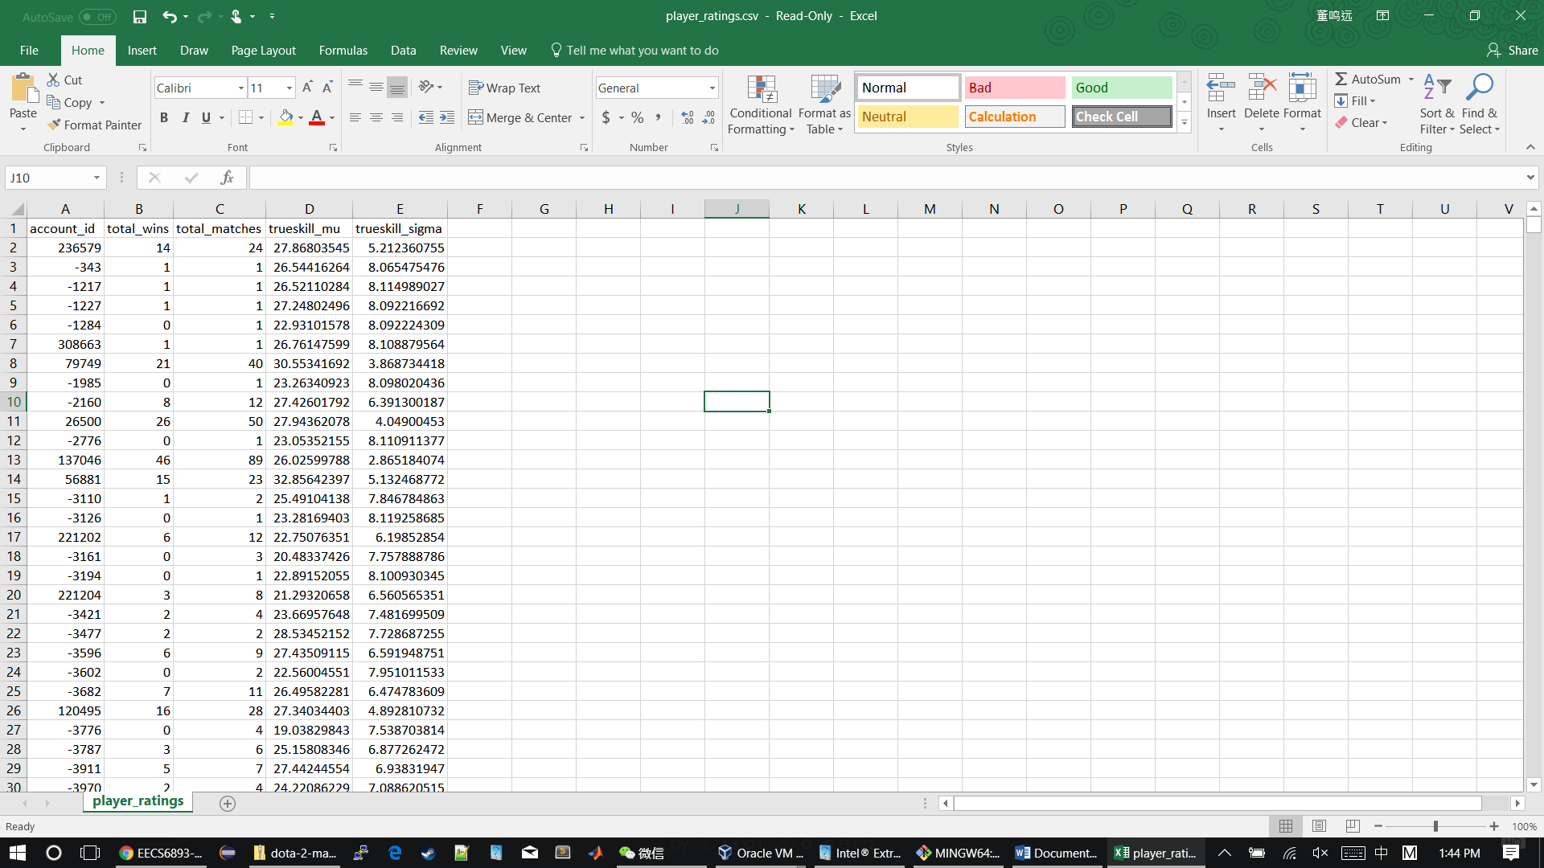

1. Hbase queries
2. Describe Hbase “PlayerRatings” table

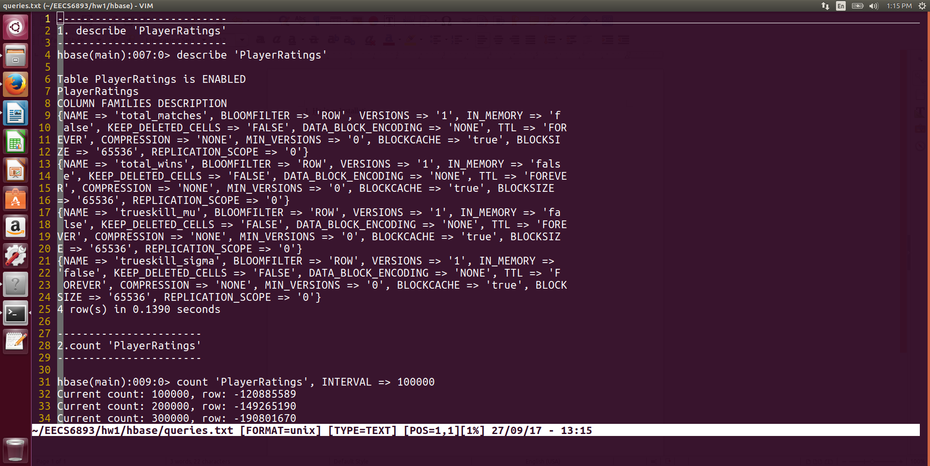

1. Count total rows in “PlayerRatings” table and set INTERVAL to 100000

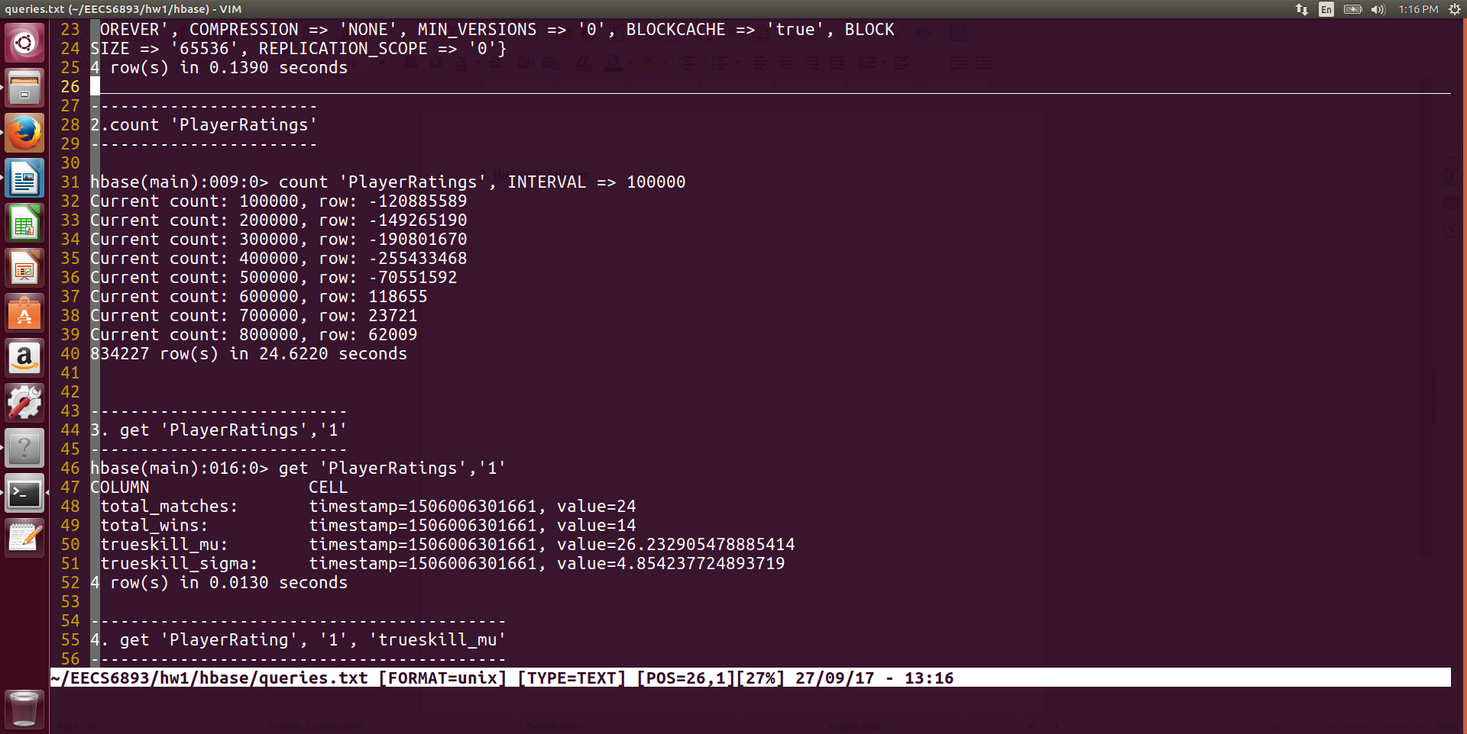

1. Get 1 row from table

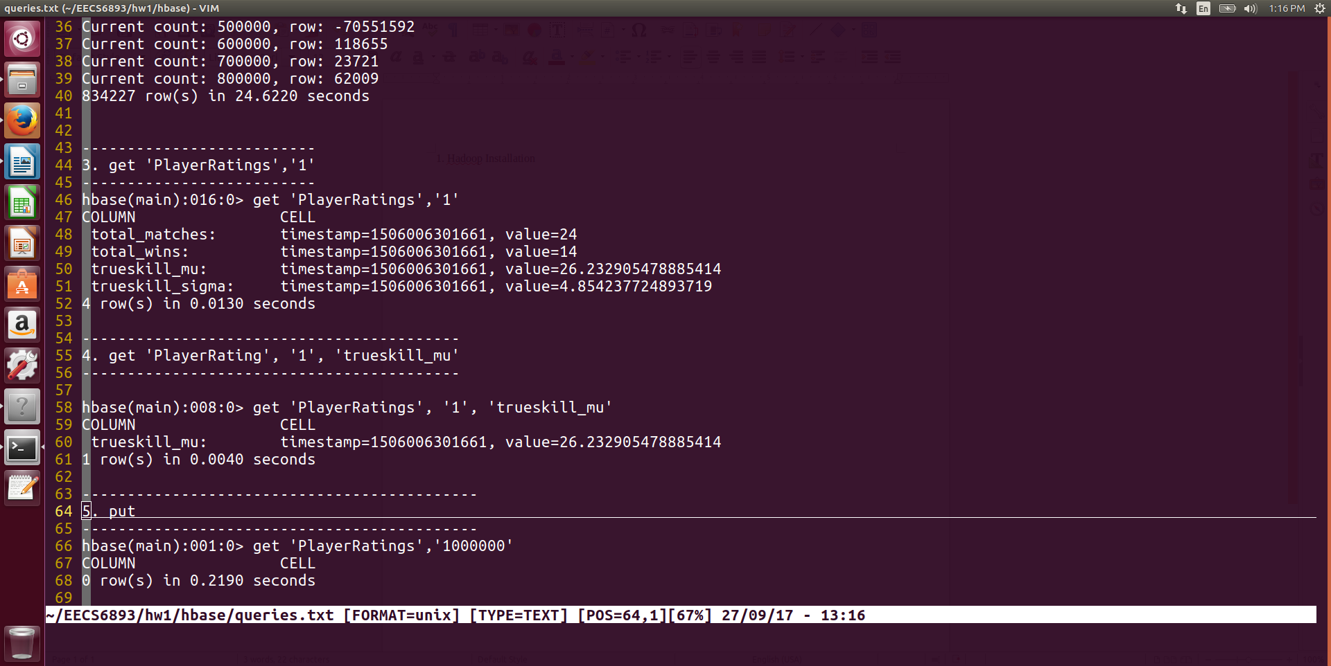

1. Get 1 element from table

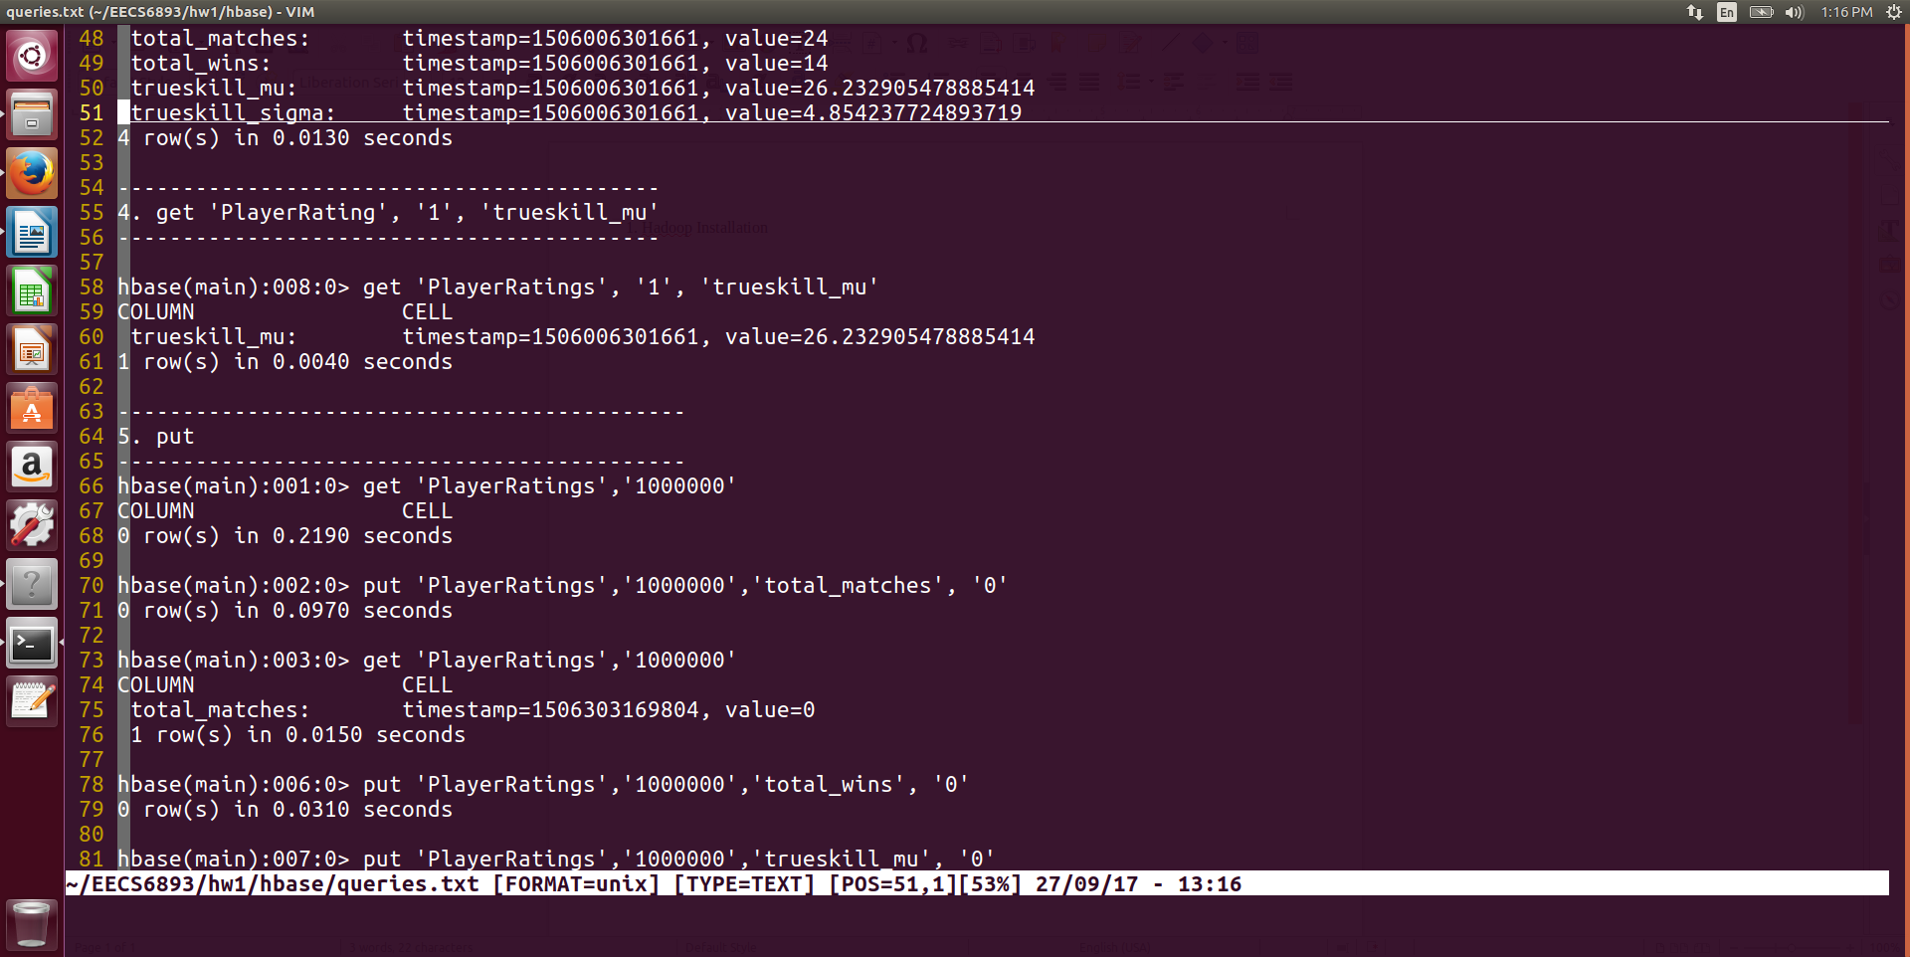

1. Put 1 row into table

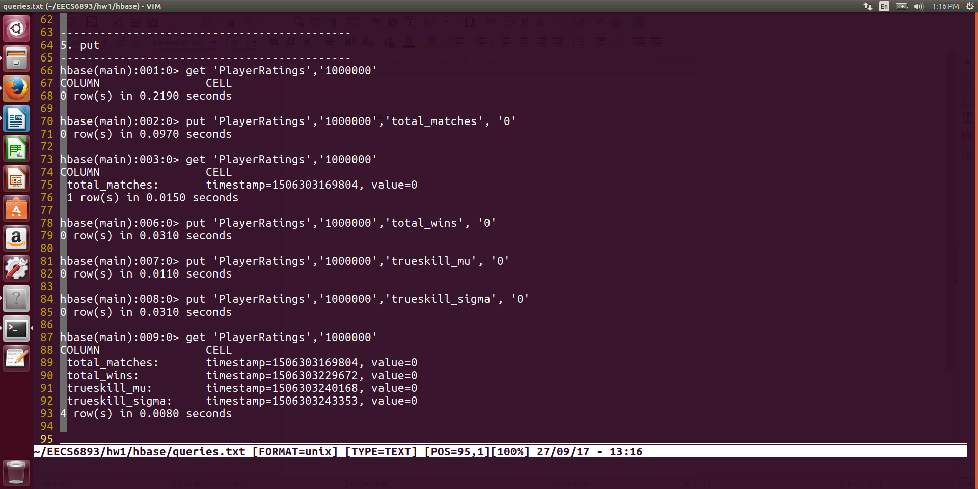

# Hive Query

## Dota2 Dataset

1. Create table and load dataset

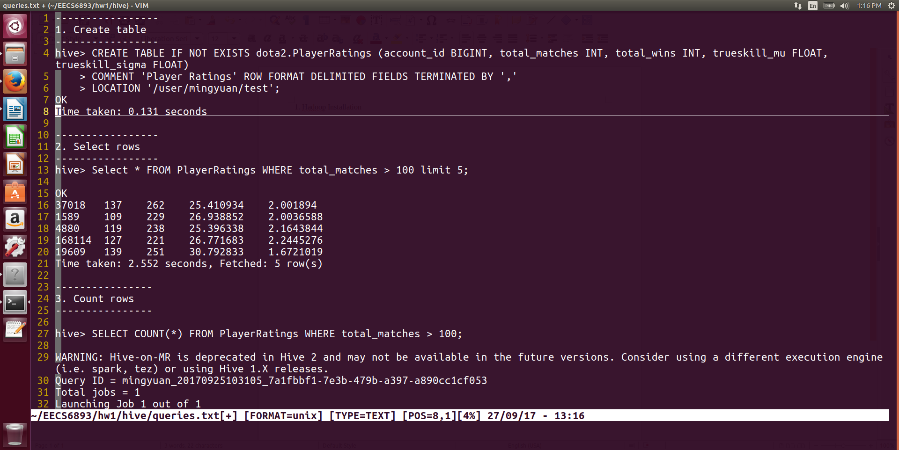

1. Select 5 players who have player more than 100 games



1. Row count

Let’s see how many players out of 834227 have played more than 100 games.

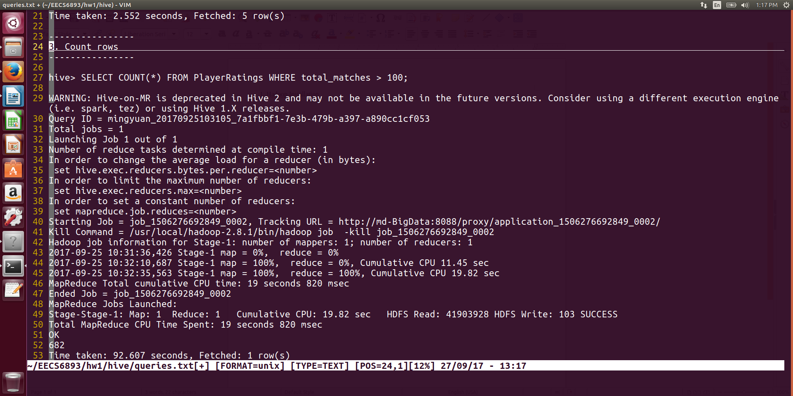

The answer is 682, which is a small number. It means only ~0.1% players in this dataset has played more than 100 games. Not as same as I expected.

1. More complex selection

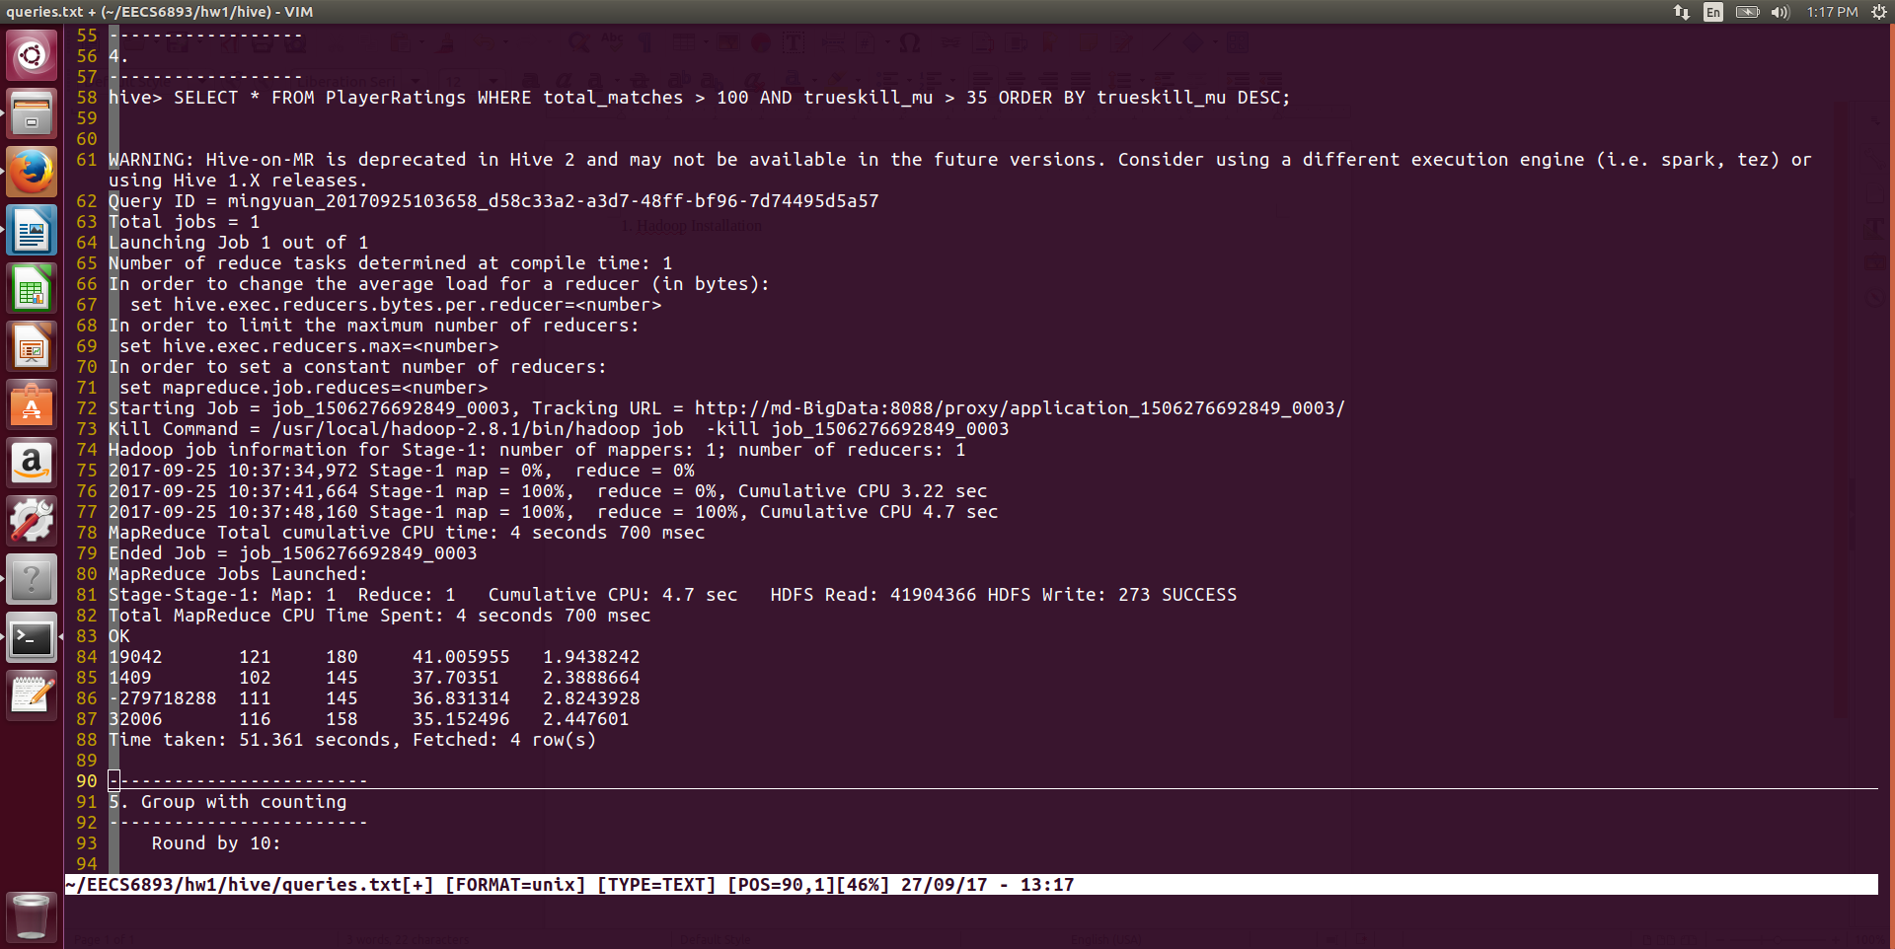

Select players who have played more than 100 games and have high trueskill score. This query only returned 4 players.

1. Group by number of games played

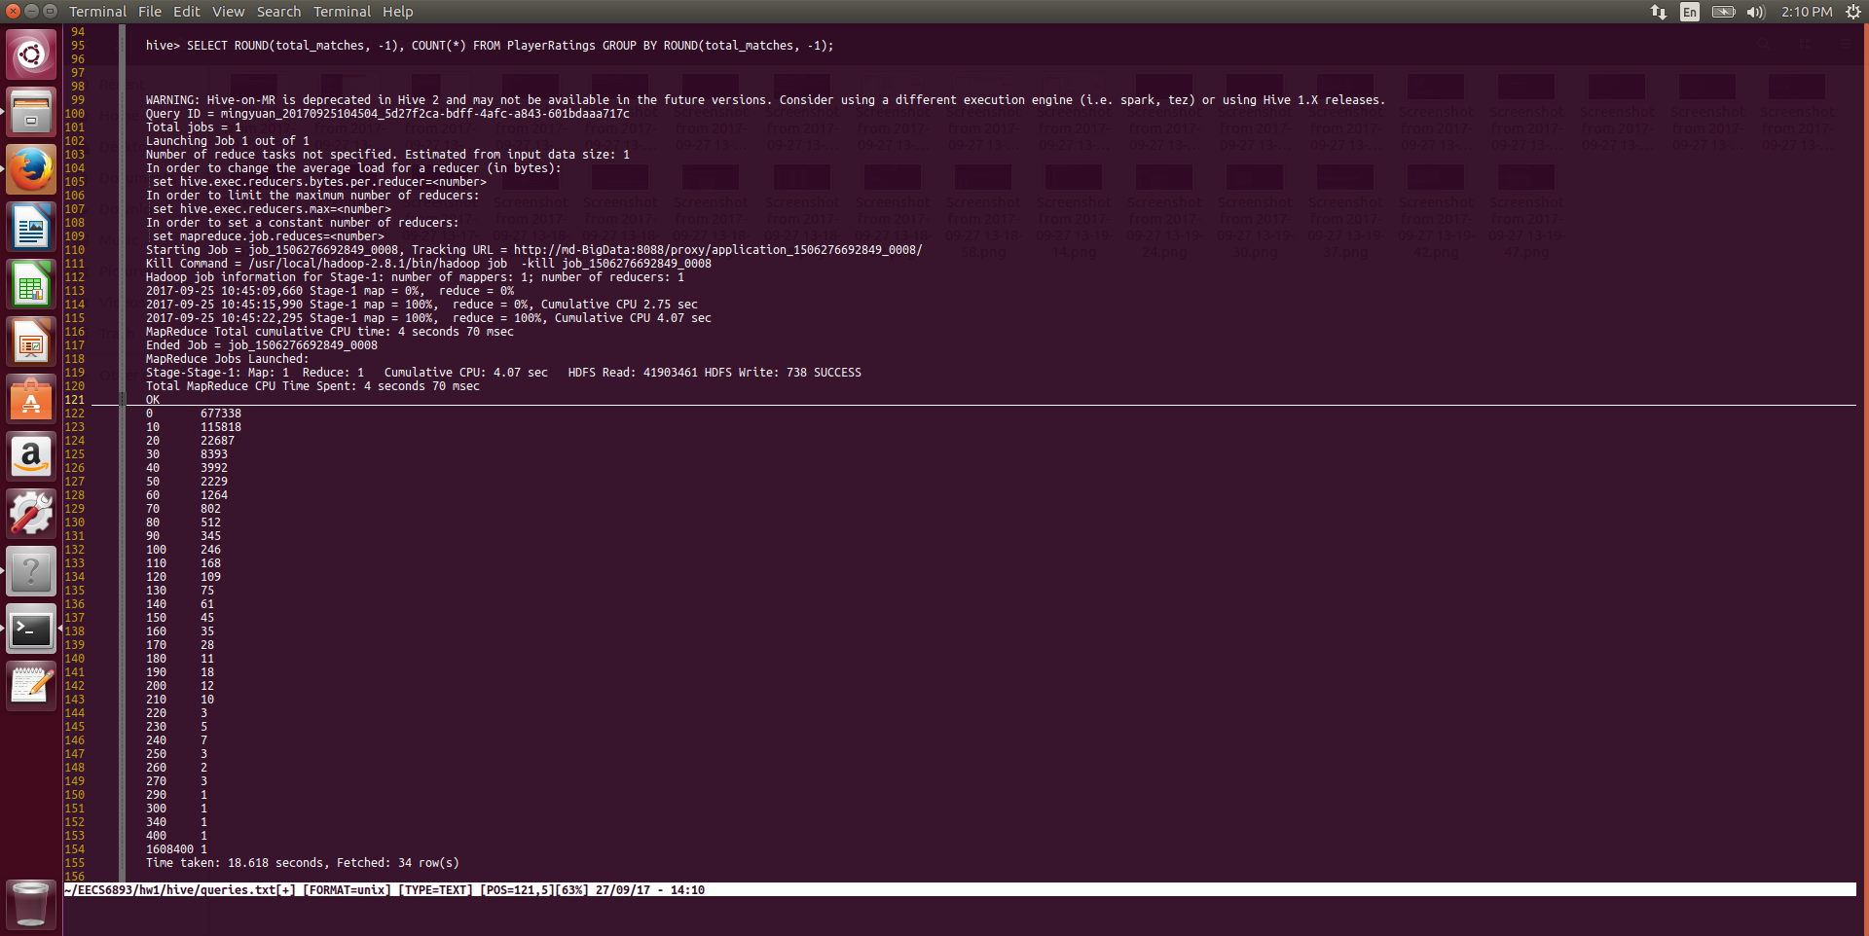

1. Find the maximum trueskill score

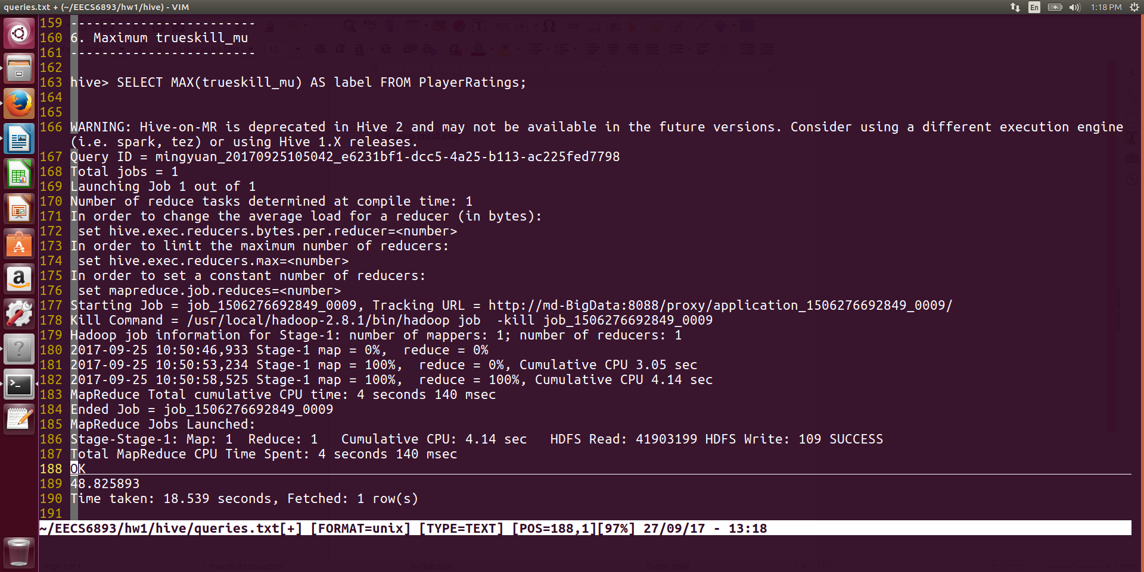

## San Francisco Crime Dataset

1. Dataset Example

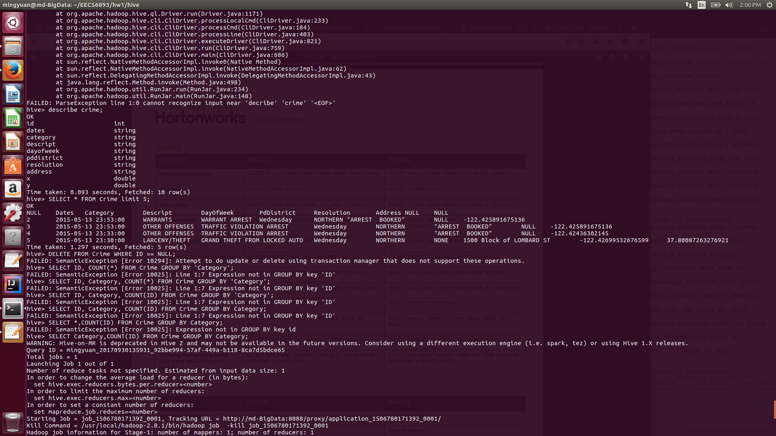

1. Count crime numbers grouped by crime category

Query: SELECT Category, COUNT(*) AS cnt GROUP BY Category ORDER BY cnt DESC;

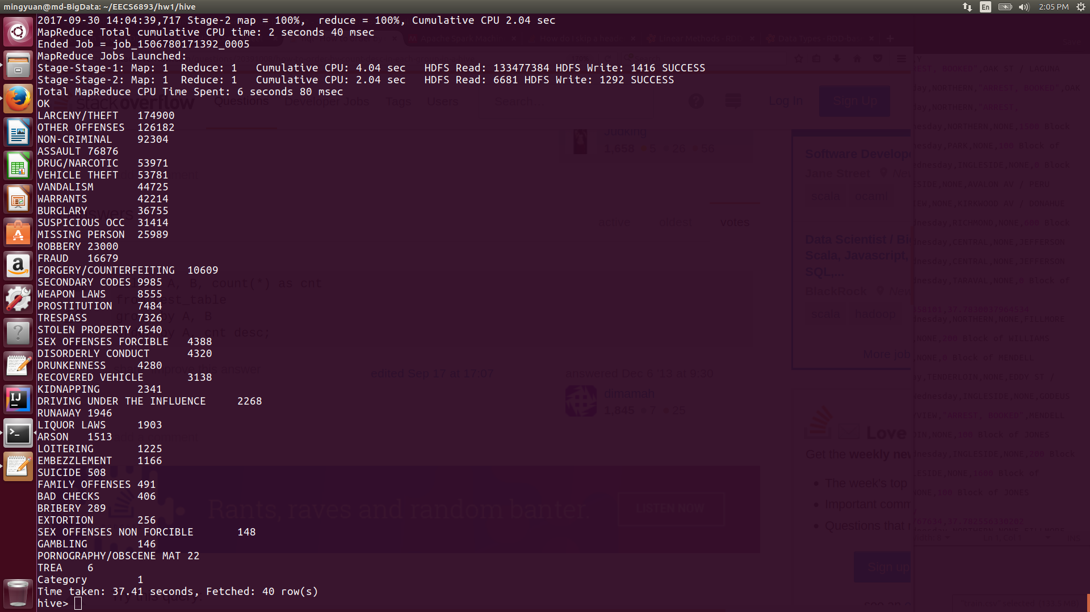

# Airline Dataset Analysis

## Hadoop

1. Hadoop Job
2. Runner class

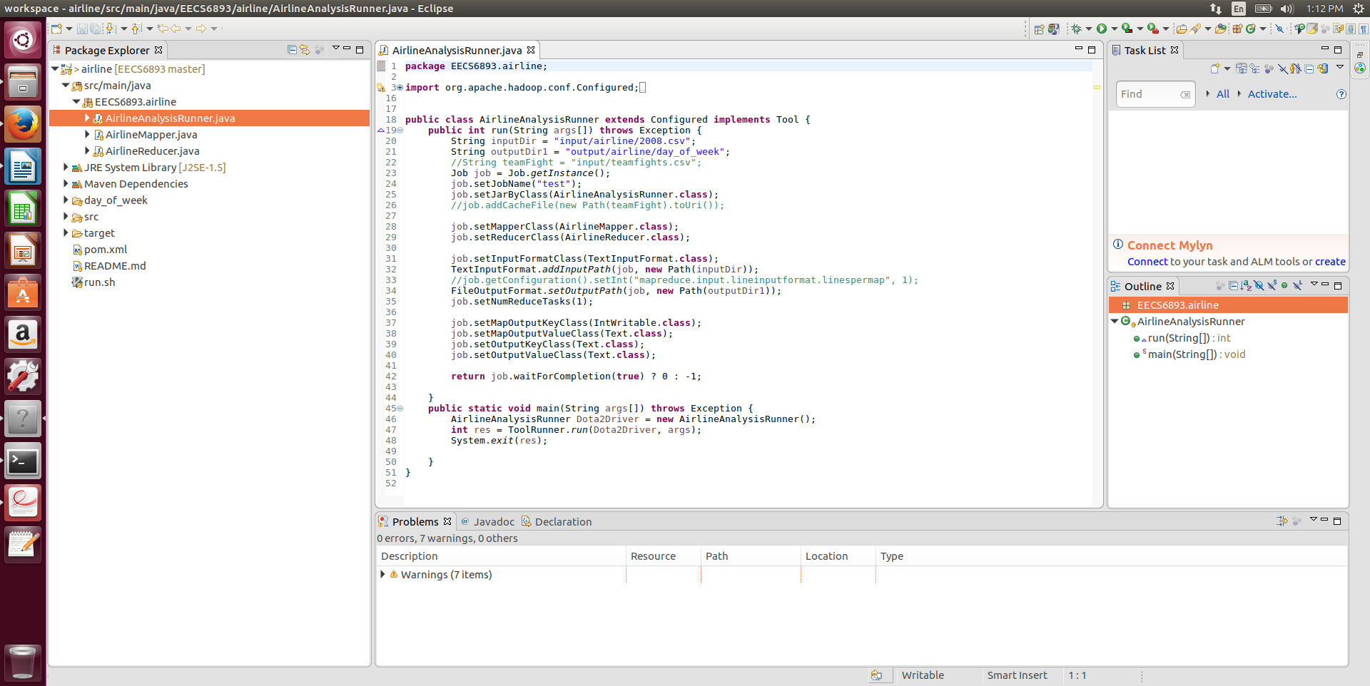

1. Mapper class

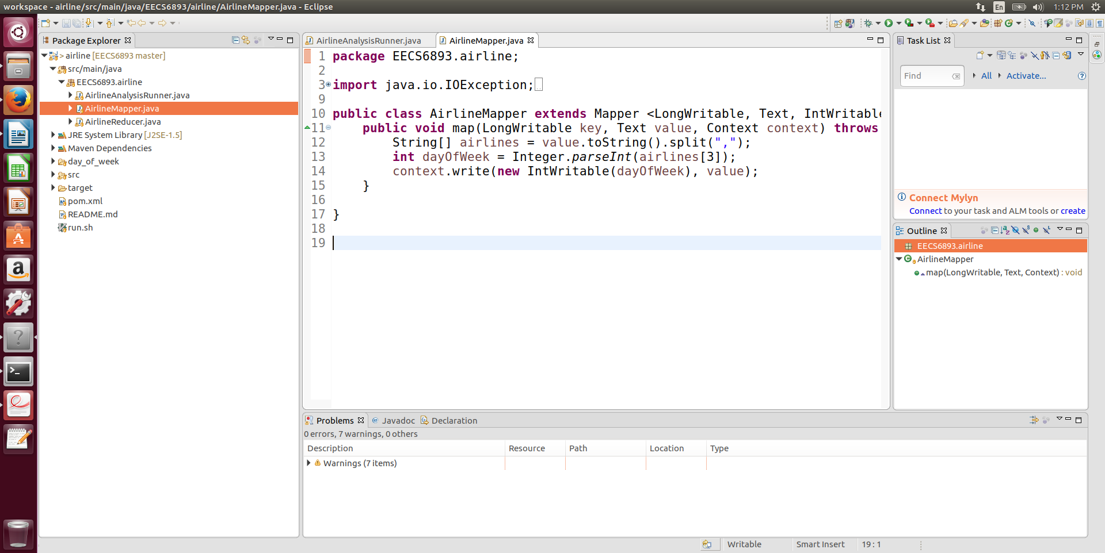

1. Reducer class

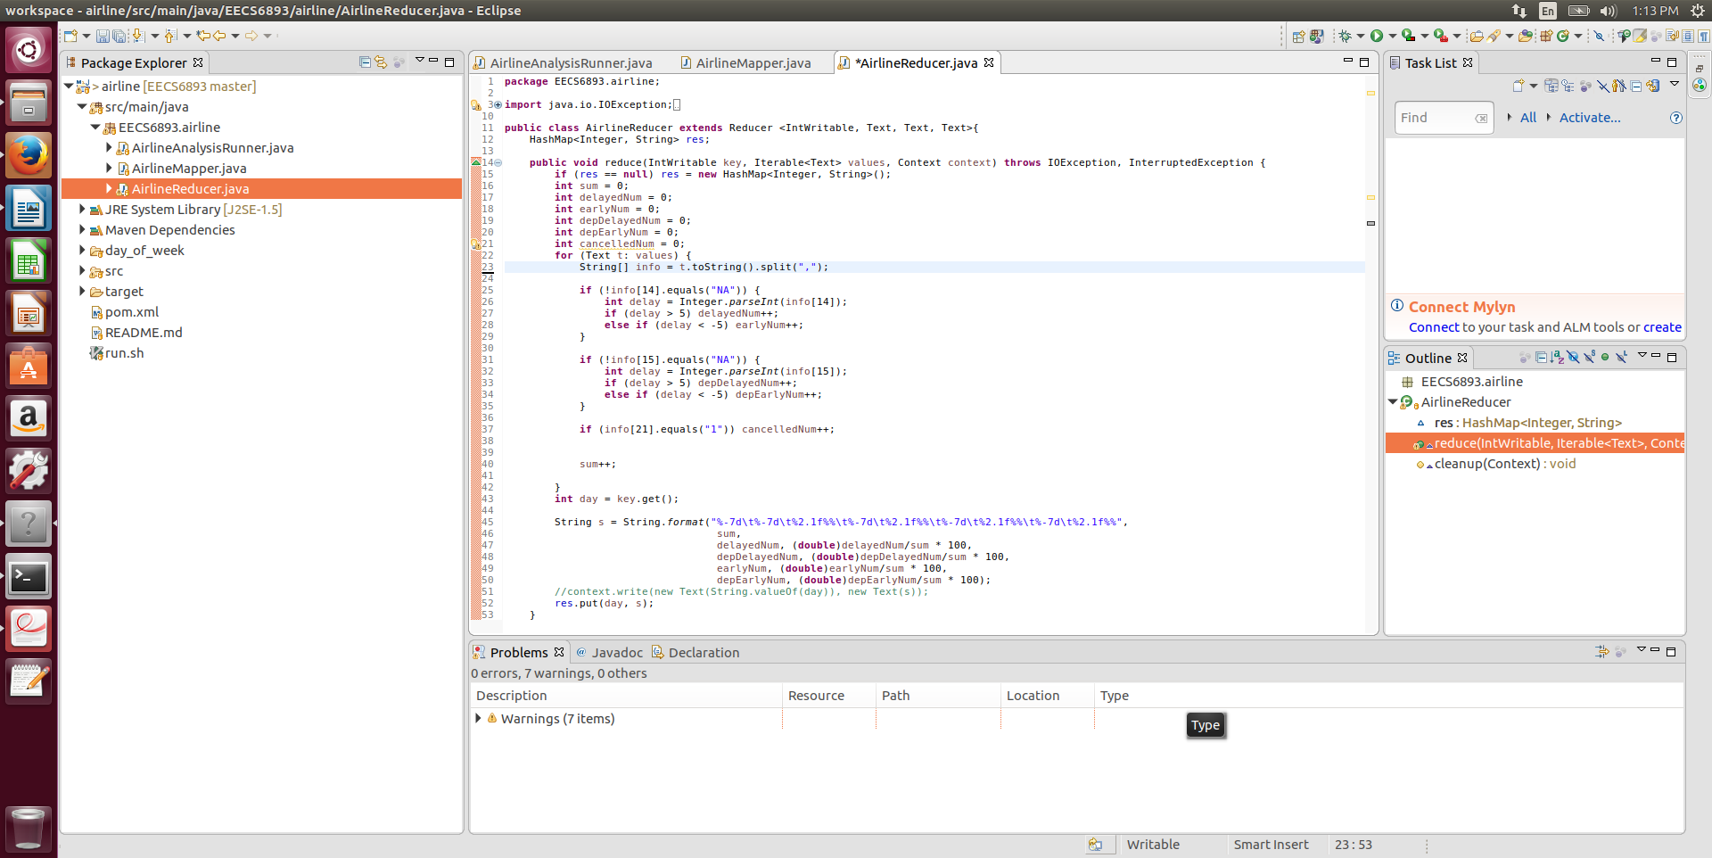

1. Result

In this MapReduce job, I am trying to find the Airline delay corresponding to Day_Of_Week information. And it is obvious that airlines in Friday have higher arrive and departure delay rates. Also, we can see that around 40% of airlines arrived 5 mins earlier than expected arriving time, but only about 17% of airlines take off 5 mins earlier than scheduled departure time! It could be possible that many of the airline flying time is less than expected flying time and needs further investigate.

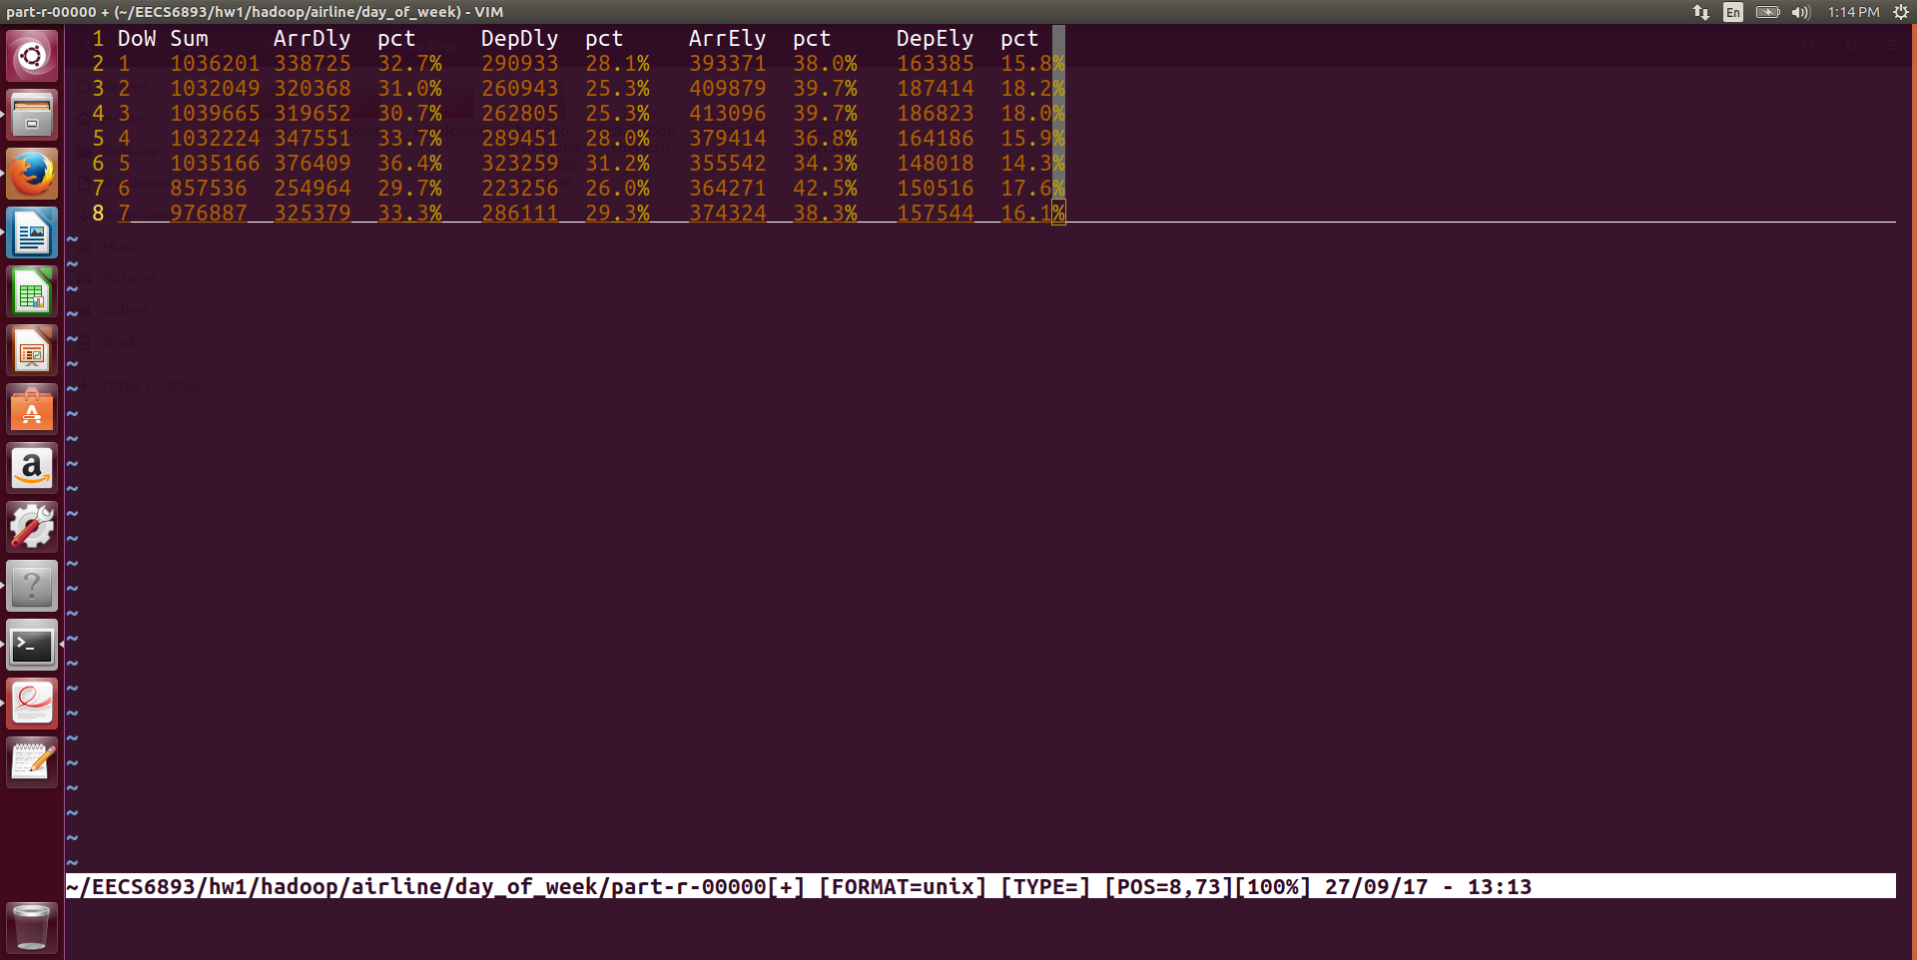

## Spark

1. Spark job

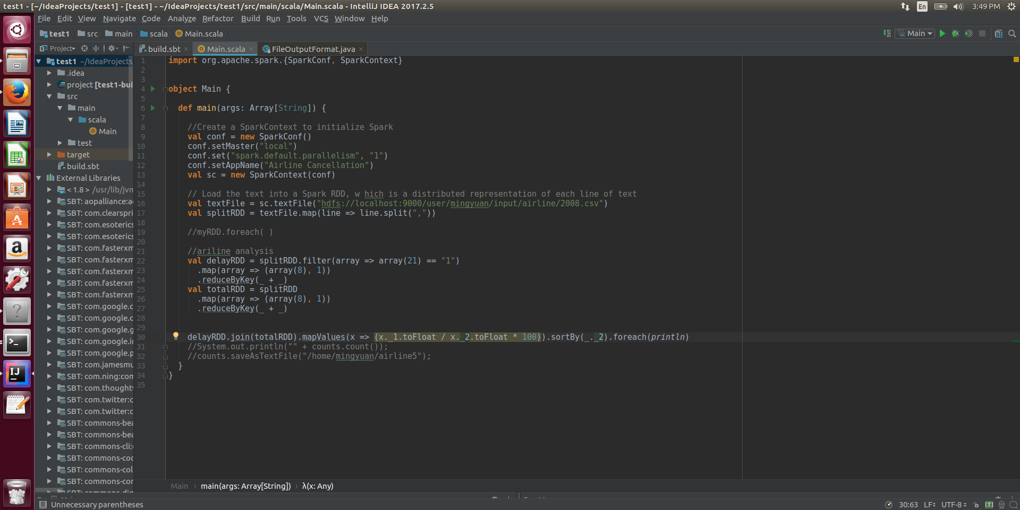

1. Result

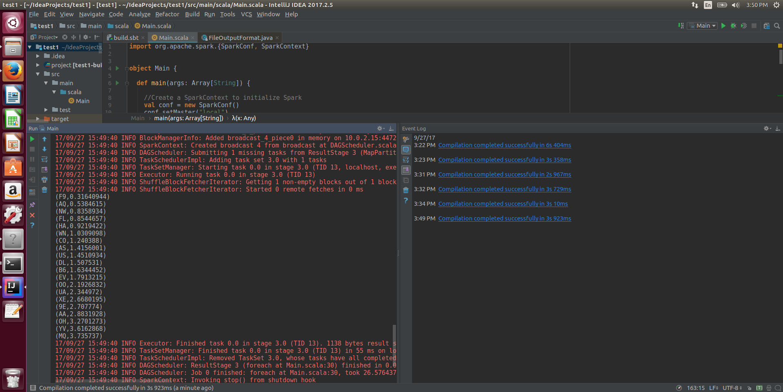

We can see the highest cancelation rate is Envoy Air(MQ)’3.7% and the lowest cancelation rate is Frontier Airline(F9)’s 0.32%, which is only one tenth of the highest rate. Delta has the lowest cancelation rate 1.51% comparing to the other two big airline companies America Airline (2.88%) and United Airline (2.34). So, Delta might be a better choice if you don’t want your flying to be canceled.

# Bitcoin Dataset Analysis

## Hadoop

1. Hadoop Jobs

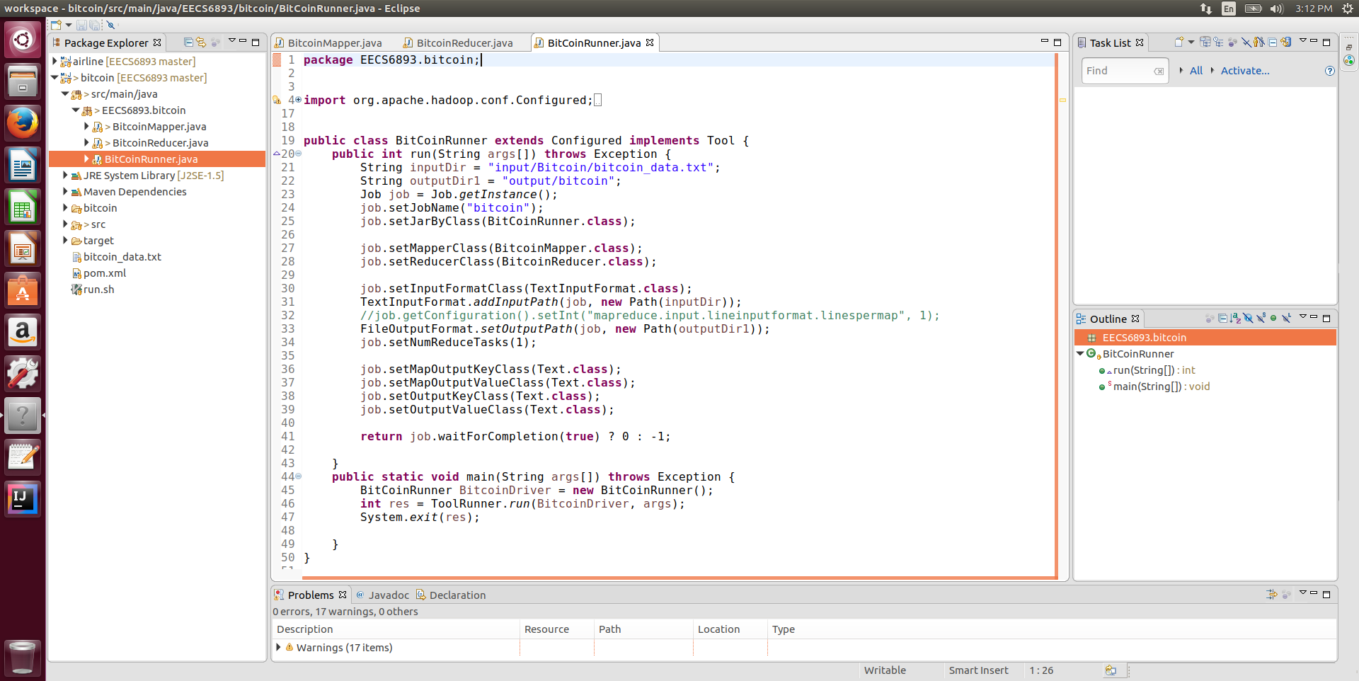

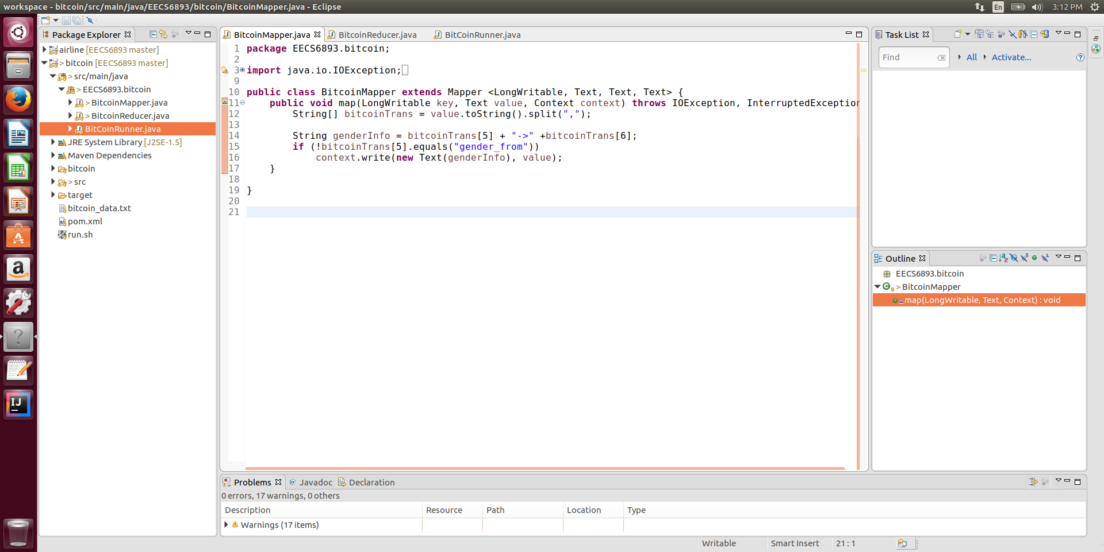

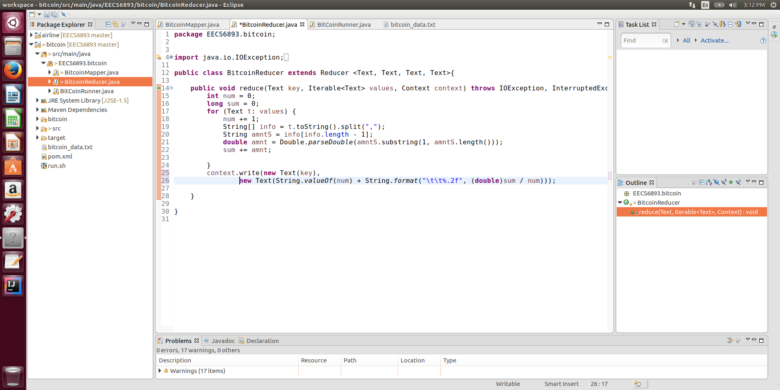

1. Result

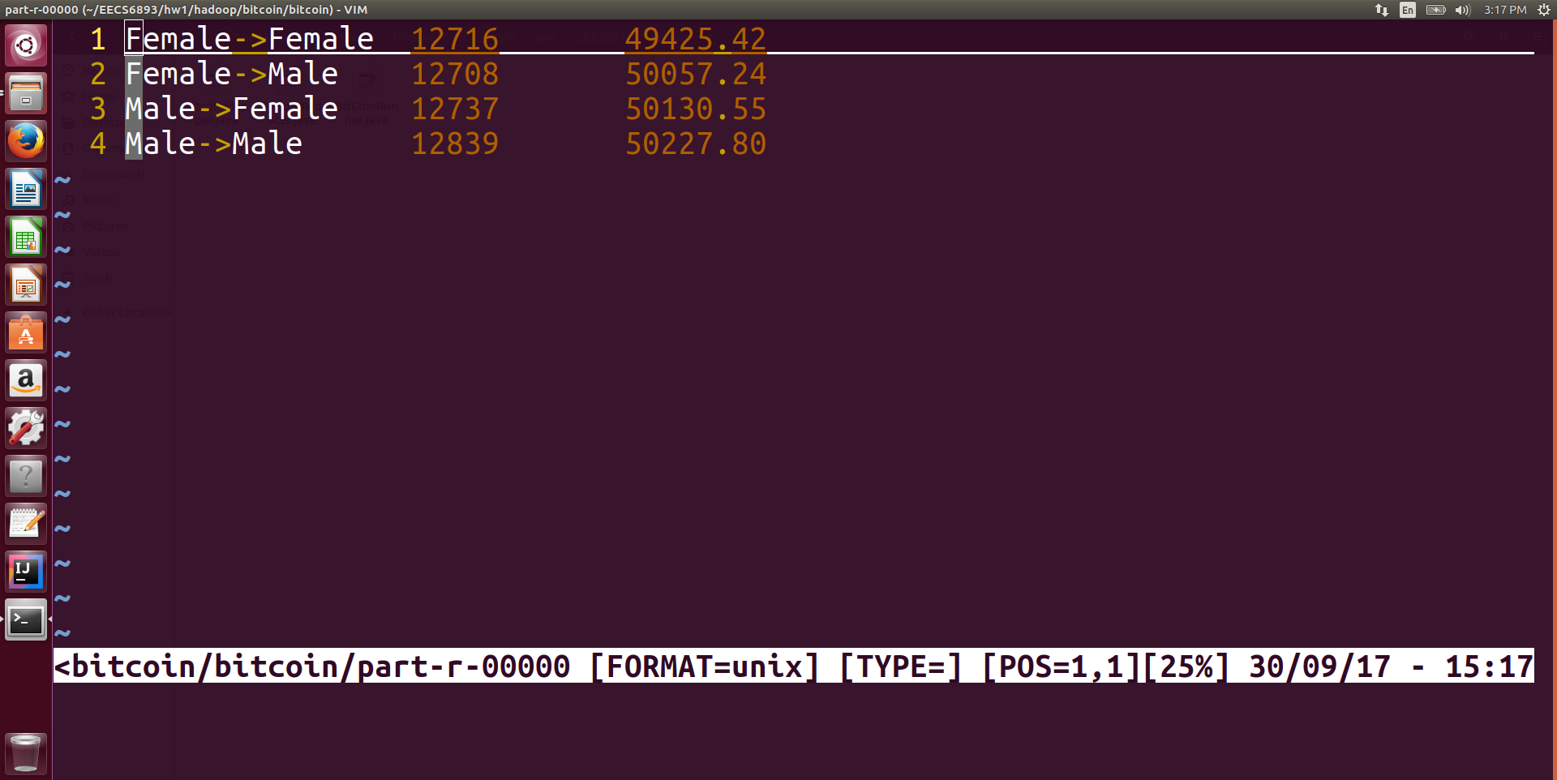

As we can see, the Hadoop MapReduce job output shows us the average amount of dollars in each transaction between genders. Female to female has the lowest average transaction amount 49425.42 and male to male has the highest average transaction amount 50227.80. Although the difference between genders is subtle (1.6% between F-F and M-M), this fact still shows that males tend to transact more amount of money in each transacation.

## Spark

1. Spark job

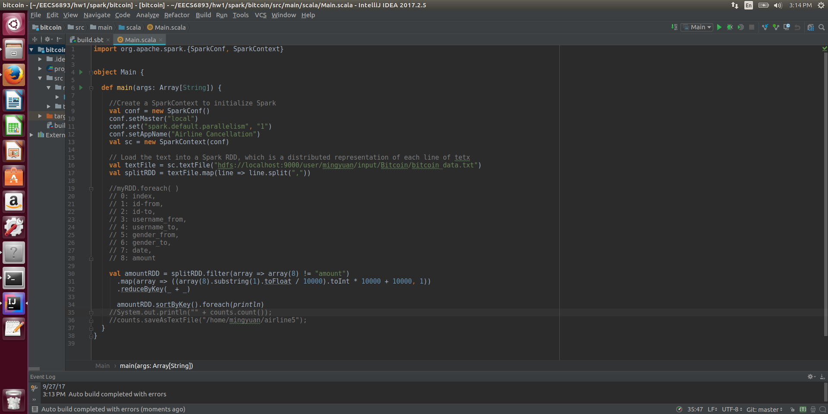

1. Result

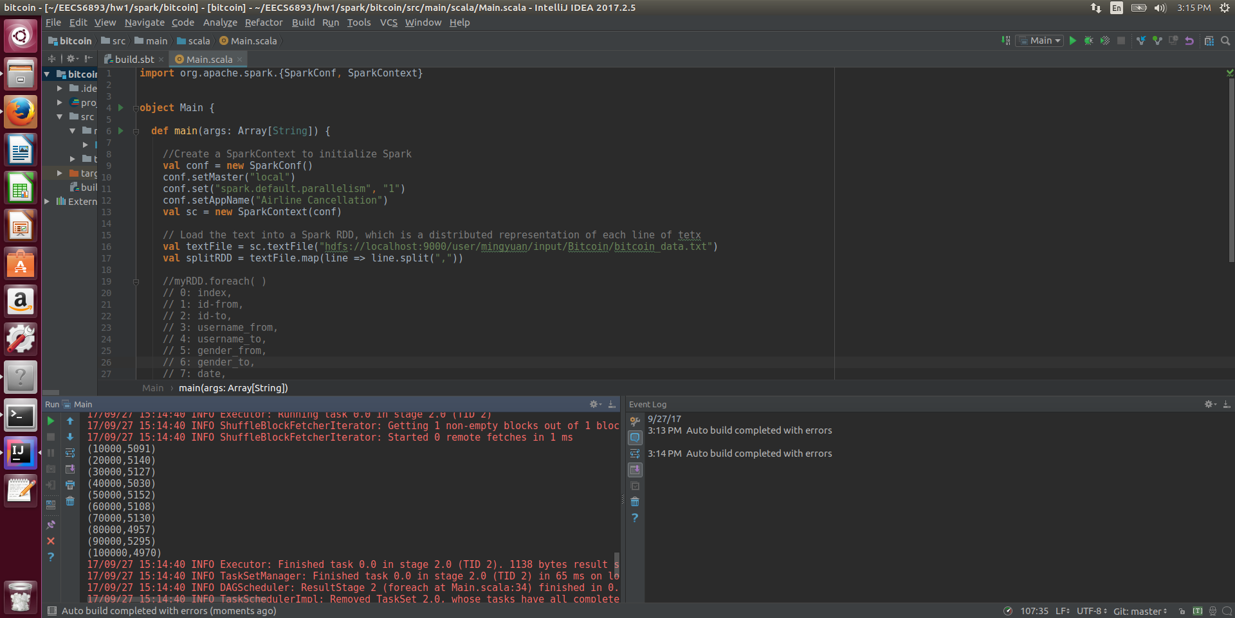

Here I want to investigate the amount of money in each bitcoin transaction. It seems that the amount of money in each transaction are almost evenly distributed from 0 ~ 90000 dollars given an interval of 10000, which is different from what I expected. My previous thought is that people are willing to do large amount transaction using bitcoin. And we can see that many people are using bitcoin to send large amount of money (~$100000).

# Other analysis

## Dota2 dataset linear regression

1. Load data
   1. Define schema

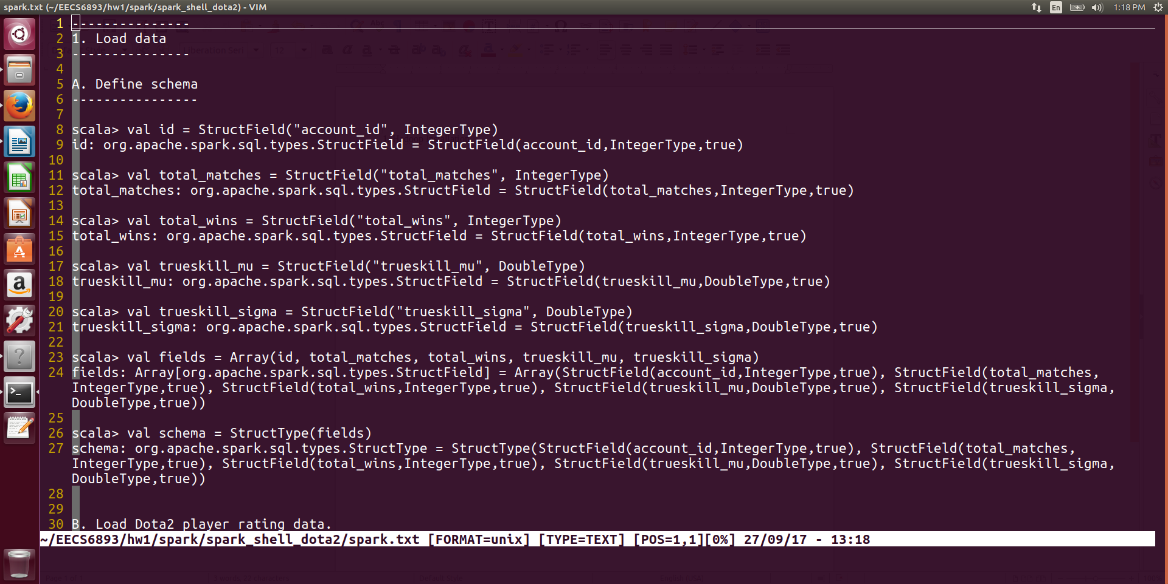

* 1. Load Dota2 player rating data

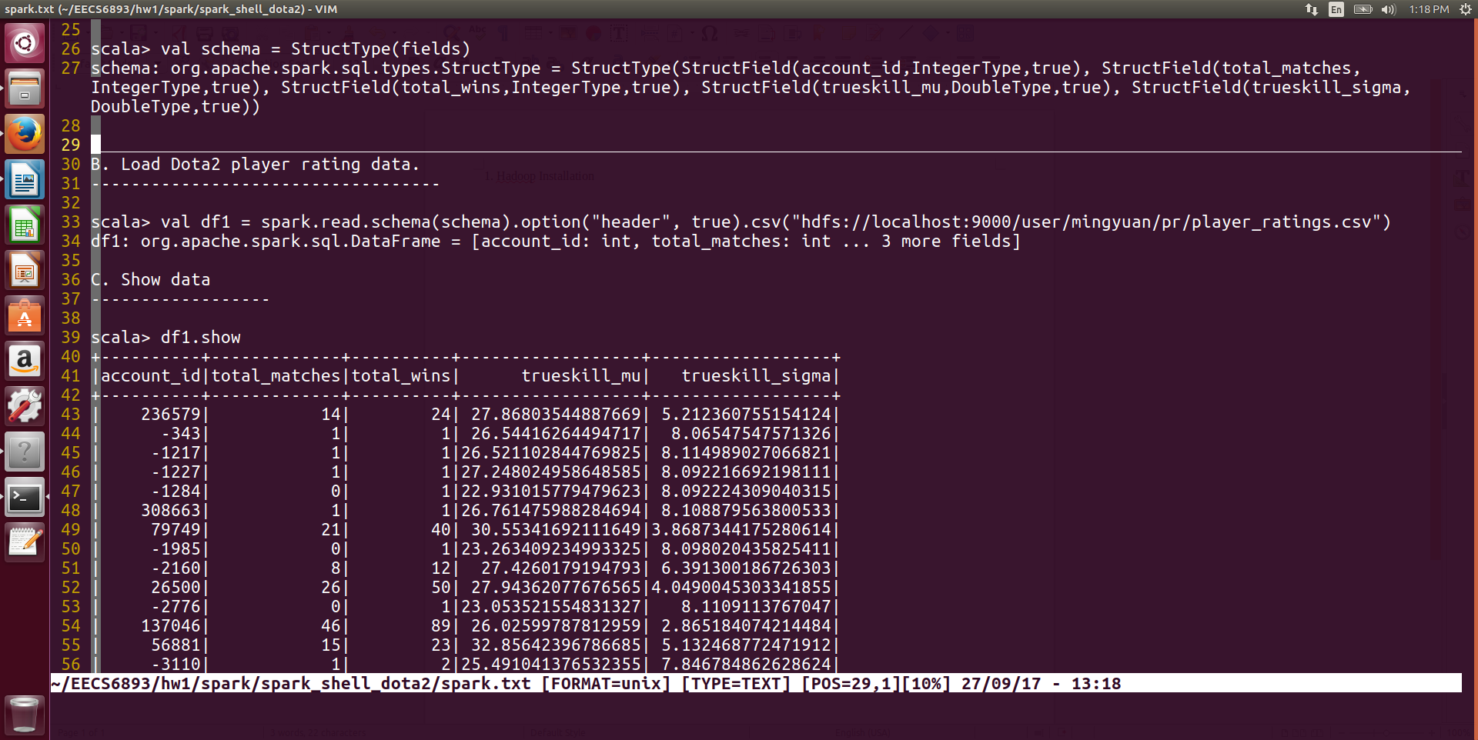

* 1. Show data

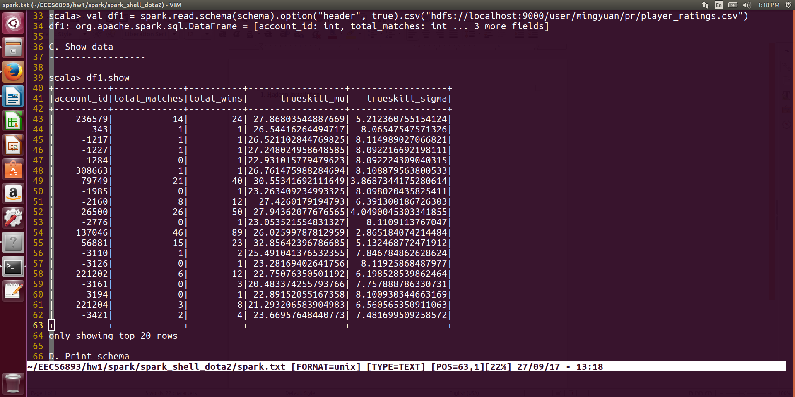

* 1. Print schema

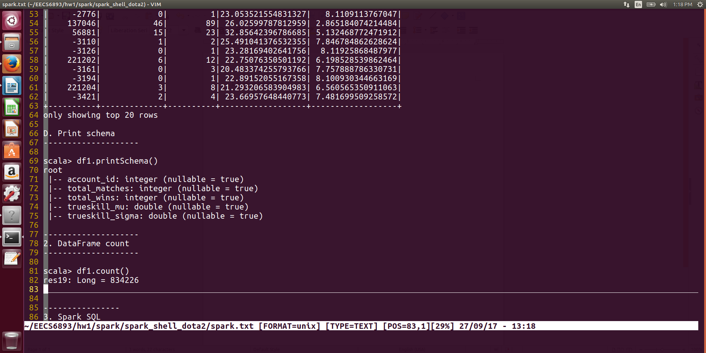

1. DataFrame count

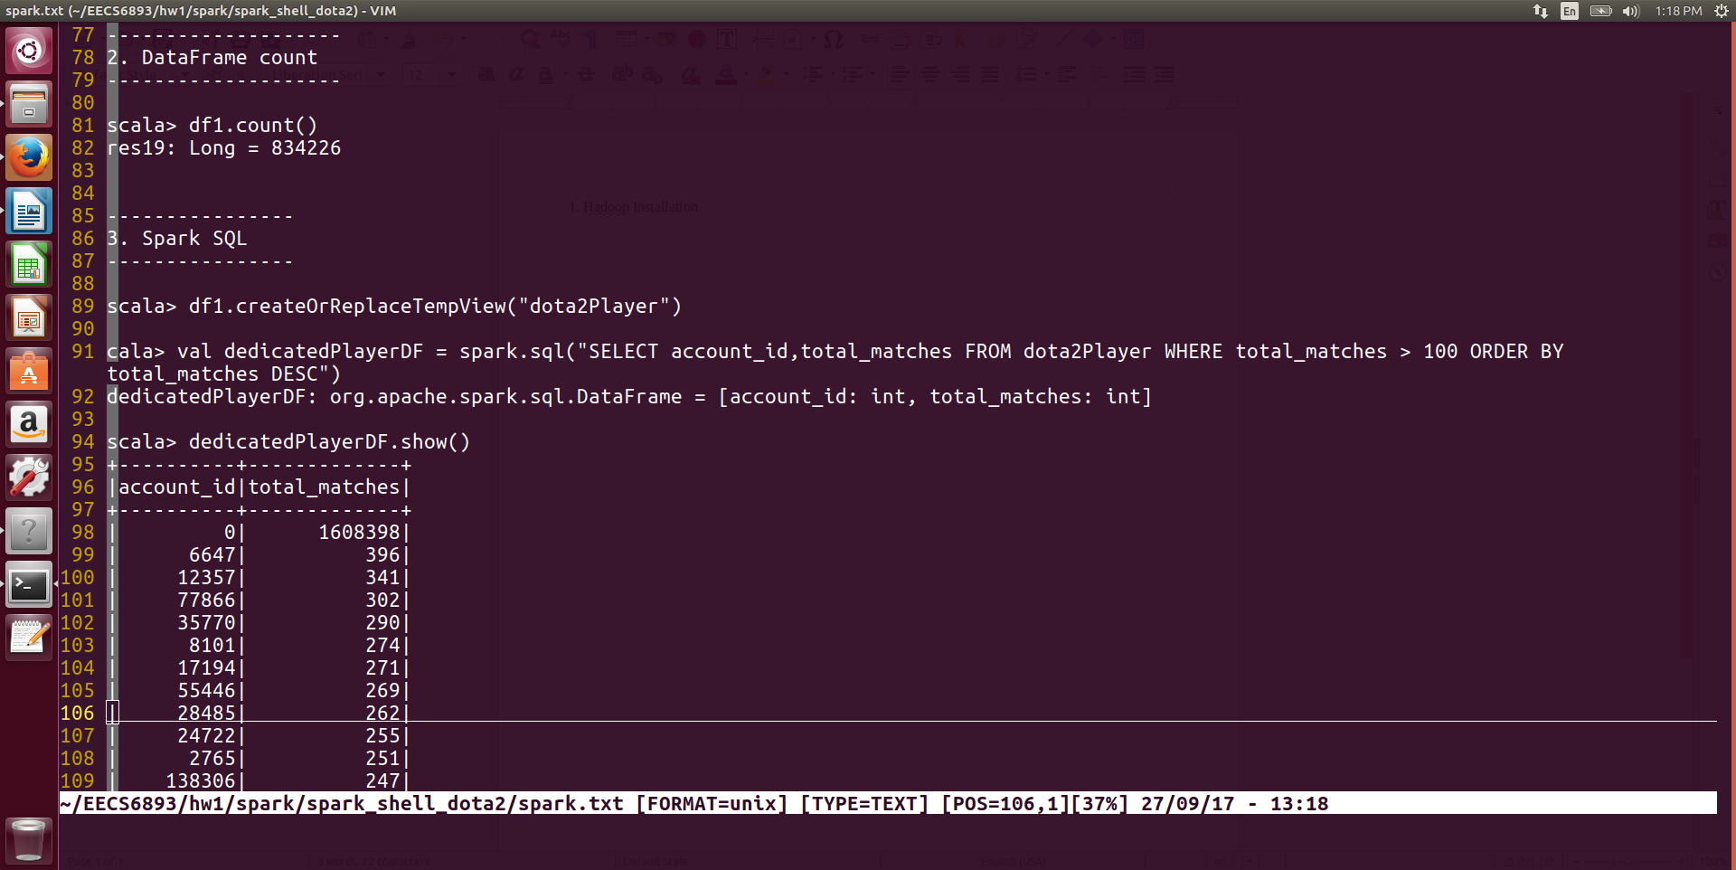

1. Spark SQL

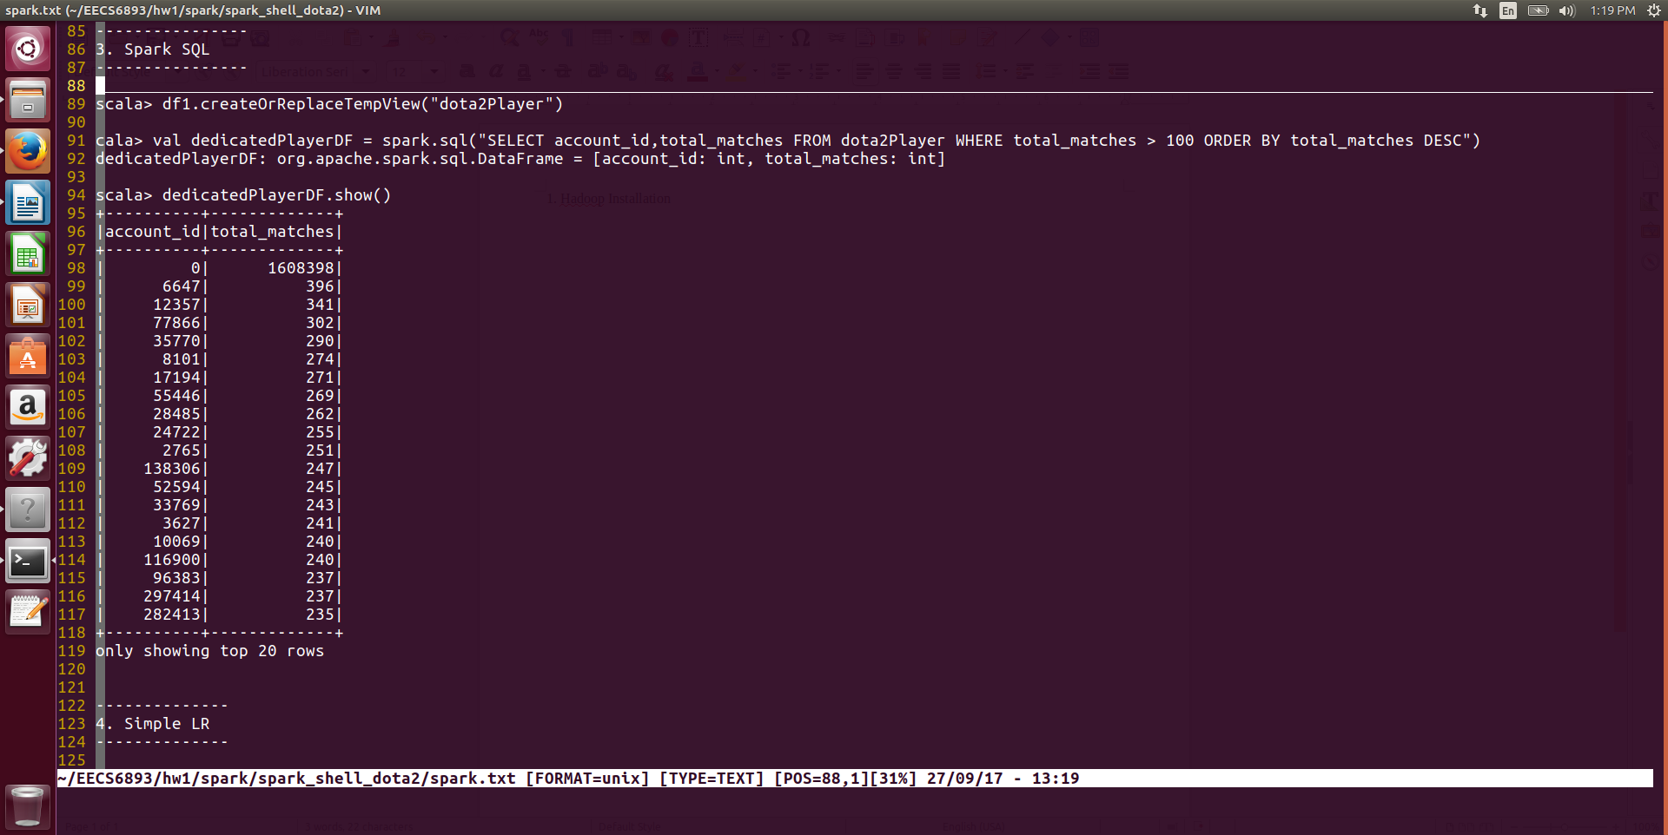

Select player who has played more than 100 games. There is a player who has played 1608398 which is impossible. Might be a problem caused by csv header.

1. Naïve Linear Regression
   1. Features assembler

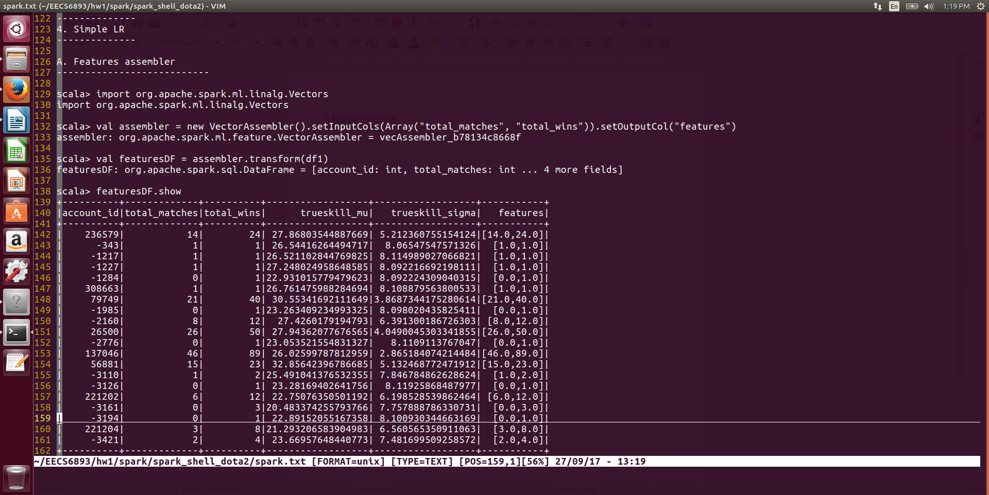

* 1. Change column names

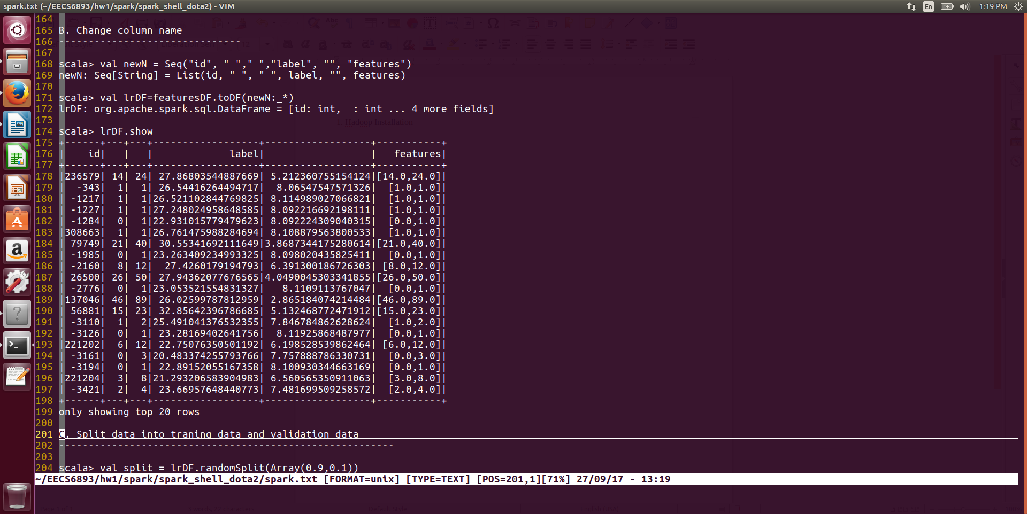

* 1. Split data into training set and validation set

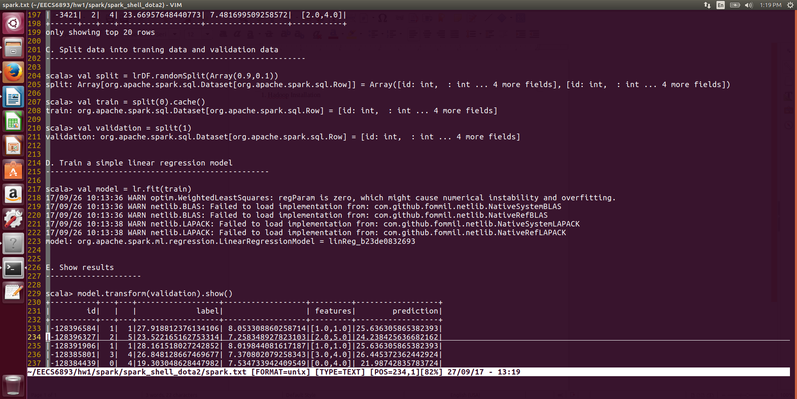

* 1. Train a simple LR model



* 1. Show results

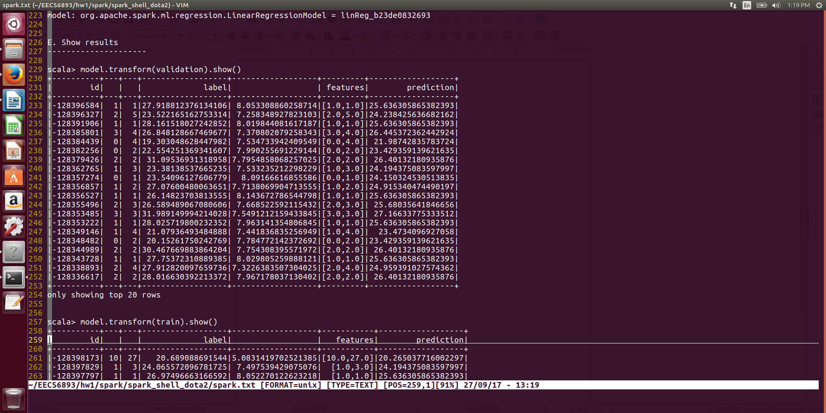

Validation Set

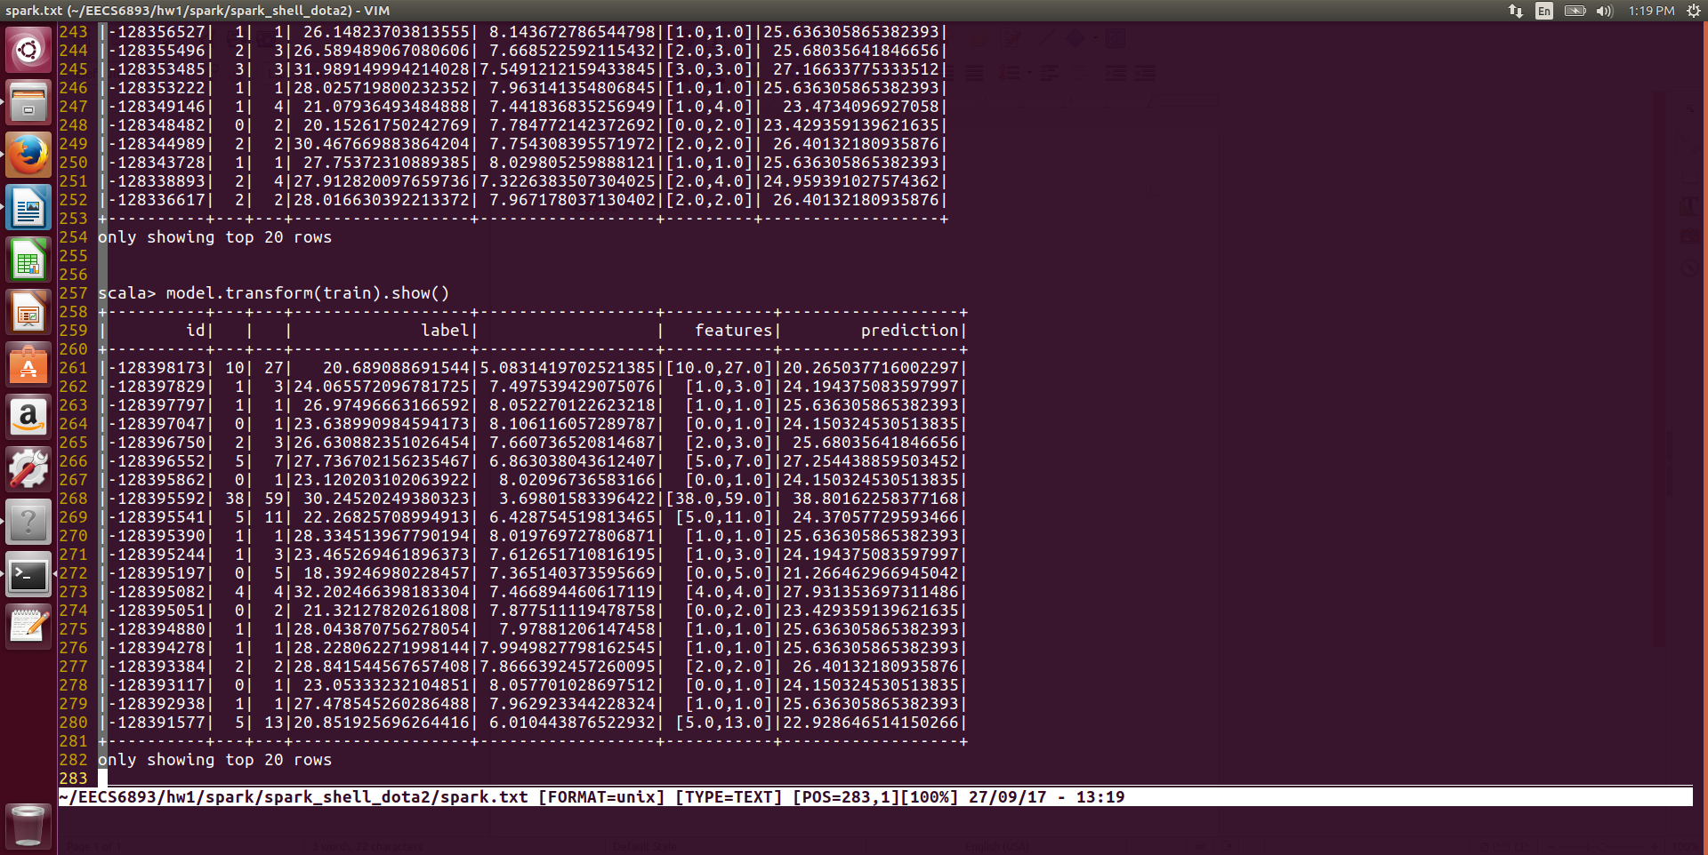

Training Set

## Human Resource dataset decision tree prediction

## 1. Code

**import** org.apache.spark.{SparkConf, SparkContext}

**import** org.apache.spark.mllib.linalg.Vectors

**import** org.apache.spark.mllib.regression.LabeledPoint

**import** org.apache.spark.mllib.tree.DecisionTree

**object** Main {

**def** main(args: Array[String]) {

**val** conf = **new** SparkConf()

conf.setMaster("local")

conf.set("spark.default.parallelism", "1")

conf.setAppName("HR")

**val** sc = **new** SparkContext(conf)

**case class** HR(id: Int,

sat: Double,

last_evl: Double,

num_p: Int,

amh: Int,

tsc: Int,

wa: Int,

left: Int,

pro: Int,

sales: String,

sala: String)

**def** parseHR(str: String): HR = {

**val** line = str.split(",")

*HR*(line(0).toInt, line(1).toDouble, line(2).toDouble, line(3).toInt,

line(4).toInt, line(5).toInt, line(6).toInt, line(7).toInt,

line(8).toInt, line(9), line(10))

}

**val** textRDD = sc.textFile("hdfs://localhost:9000/user/mingyuan/input/HR/HR_comma_sep.csv")

**val** header = textRDD.first()

**val** dropHeaderRDD = textRDD.filter(row => row != header)

**val** hrRDD = dropHeaderRDD.map(parseHR).cache()

**val** salesRDD = hrRDD.map(line => (line.sales, 1)).reduceByKey(_ + _)

salesRDD.foreach(*println*)

**var** salesMap: Map[String, Int] = *Map*()

**var** index: Int = 0

hrRDD.map(hr => hr.sales).distinct.collect.foreach(x => {

salesMap += (x -> index);

index += 1

})

*println*(salesMap.toString())

**var** salaryMap: Map[String, Int] = *Map*()

**var** index1: Int = 0

hrRDD.map(hr => hr.sala).distinct.collect.foreach(x => {

salaryMap += (x -> index1);

index1 += 1

})

*println*(salaryMap.toString())

**val** mlprep = hrRDD.map(hr => {

**val** sat = hr.sat

**val** eval = hr.last_evl

**val** proj = hr.num_p

**val** amh = hr.amh

**val** tsc = hr.tsc

**val** wa = hr.wa //category

**val** left = hr.left //category

**val** pro = hr.pro //category

**val** sales = salesMap(hr.sales) //category

**val** sala = salaryMap(hr.sala) //category

*Array*(left.toDouble, sat.toDouble, eval.toDouble, proj.toDouble,

amh.toDouble, tsc.toDouble, wa.toDouble, pro.toDouble, sales.toDouble, sala.toDouble)

})

mlprep.take(10).foreach(*println*)

**val** mldata = mlprep.map(x => LabeledPoint(x(0), Vectors.*dense*(x(1),

x(2), x(3), x(4), x(5), x(6), x(7), x(8), x(9))))

**val** mldata0 = mldata.filter(x => x.label == 0).randomSplit(*Array*(0.8, 0.2))(1)

**val** mldata1 = mldata.filter(x => x.label != 0)

**val** mldata2 = mldata0 ++ mldata1

**val** splits = mldata2.randomSplit(*Array*(0.7, 0.3))

**val** (trainingData, testData) = (splits(0), splits(1))

**var** categoricalFeaturesInfo = *Map*[Int, Int]()

categoricalFeaturesInfo += (5 -> 2)

categoricalFeaturesInfo += (6 -> 2)

categoricalFeaturesInfo += (7 -> salesMap.size)

categoricalFeaturesInfo += (8 -> salaryMap.size)

**val** numClasses = 2

**val** impurity = "gini"

**val** maxDepth = 9

**val** maxBins = 5000

**val** model = DecisionTree.*trainClassifier*(trainingData, numClasses, categoricalFeaturesInfo, impurity, maxDepth, maxBins)

*println*(model.toDebugString)

**val** labelAndPreds = testData.map { point =>

**val** prediction = model.predict(point.features)

(point.label, prediction)

}

**val** res = labelAndPreds.map(x => ((x._1, x._1.equals(x._2)), 1))

.reduceByKey(_ + _)

res.collect().foreach(*println*)

}

}

2. Result

a. Jobs summary

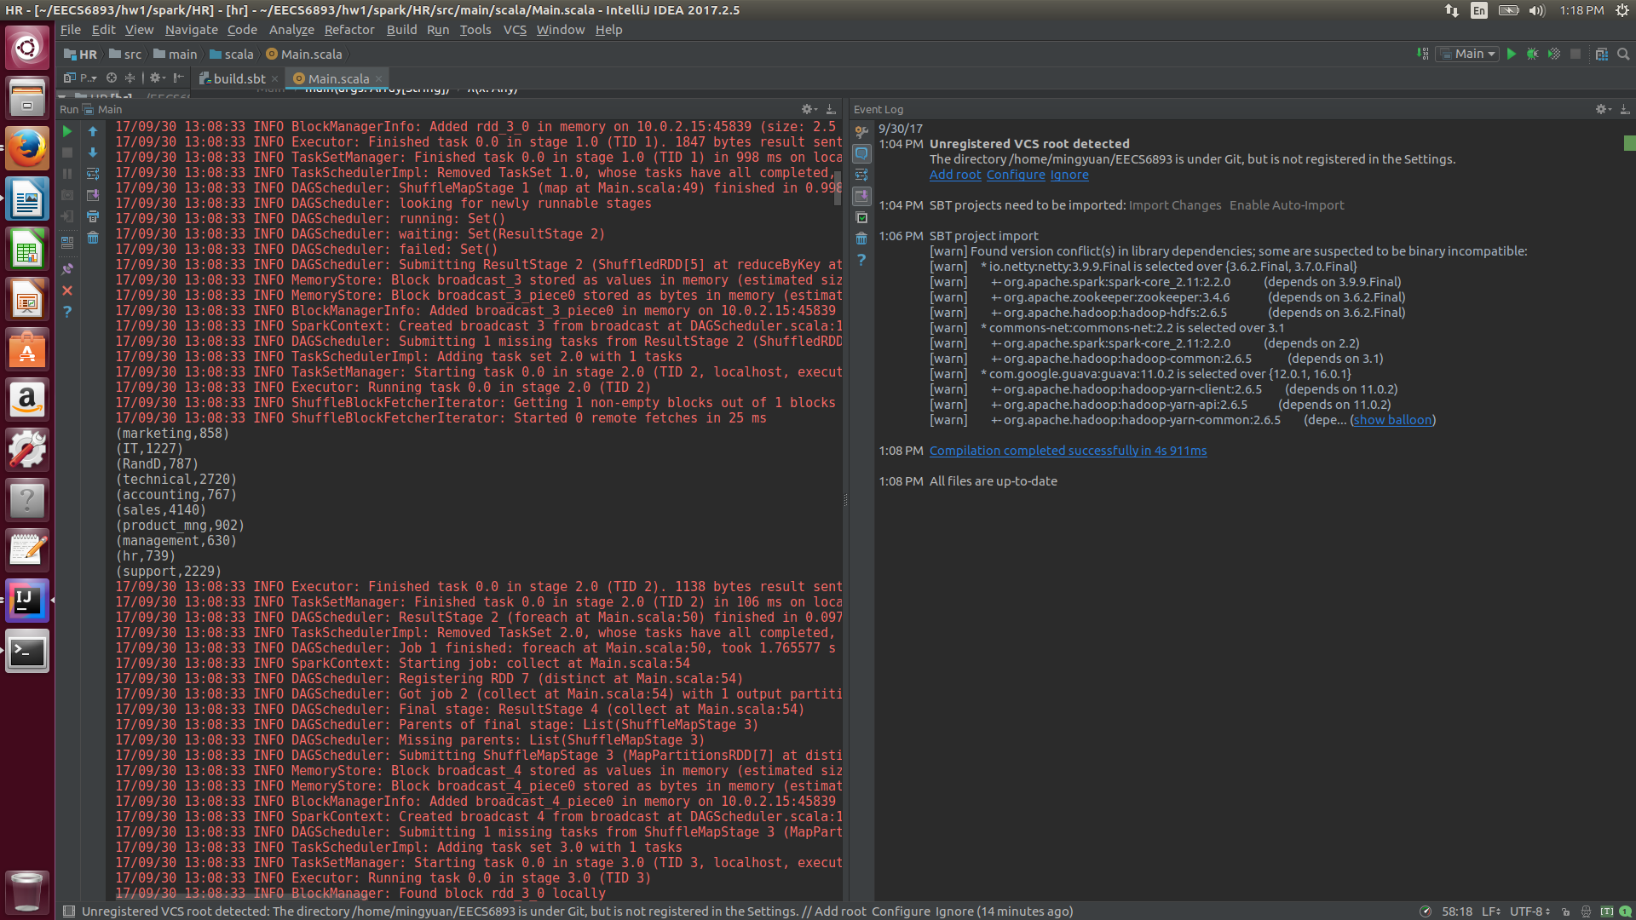

We can see that the job classes distribution is very similar to our intuition. The number of sales job is 4140, which is the most, comparing to the number management job 630.

b. Trained decision tree

Here I split the dataset into training data and test data, given the proportion 0.8,0.2. And I used the decision tree model from mllib to train a model to predict whether an employee quitted company or not given some data during his or her employment. The trained decision tree is like this:

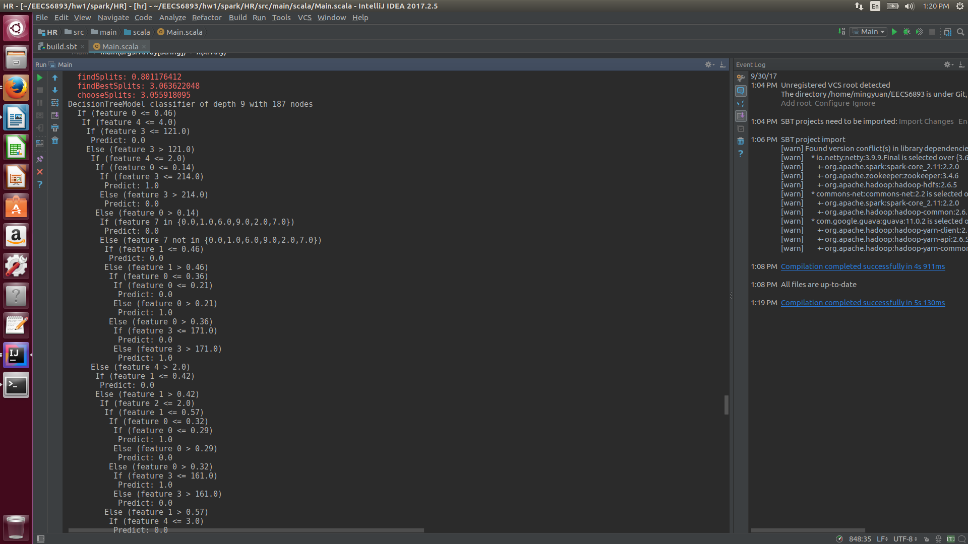

And the prediction accuracy is 95.4%

